PREAMPLIFIER FOR 432MHZ AND 1296MHZ WITH MODERN HEMT-TRANSISTOR

- by Ole Nykjær, OZ2OE
mail: nyk@get2net.dk - homepage: www.qsl.net/oz2oe

The ATF-54143 is a new E-PHEMT from Agilent (formerly HP), developed for use in low noise amplifiers from VHF to 6 GHz.

Typical specifications at 2GHz and 3V, 60 mA :
- low noise figure 0,5 dB
- high linearity 3’rd order IP 36,2 dBm
- high gain 16,6 dB

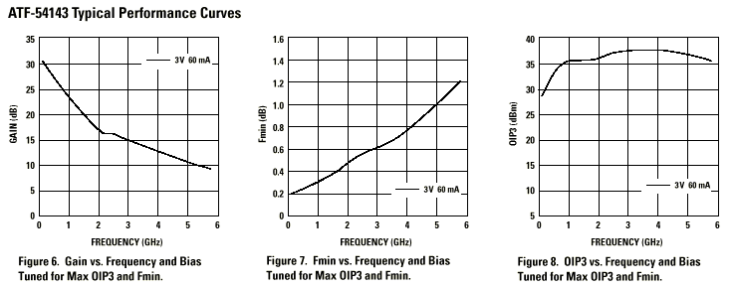

Other useful features :
- enhancement mode – no negative bias !
- easy matching for best noisefigure
- low cost

Not so useful features :
- high gain (>30 dB at VHF), can give instability
- small size 1,2 x 2 mm – you need a steady hand (so wait a couple of days !)

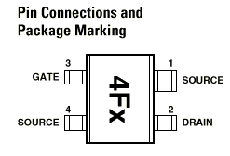

For more information look up the datasheet on Agilents homepage : www.agilent.com – pull down Products and RF & Microwave and find ATF-54143

STABLITY

An amplifier must be stable, not only around the working frequency, but also on frequencies far away.

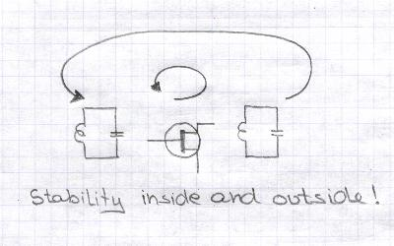

Stability can be expressed in terms of k-factor. The k-factor is calculated from the transistor s-parameters. With k>1 the circuit is unconditionally stable – so whatever you put on the input and output terminal, it will not oscillate.

Using s-parameters for ATF-54143 and with a little help from ‘ARRL Radio Designer’ circuit simulator, we get a plot of k-factor from 0,1 to 14 GHz.

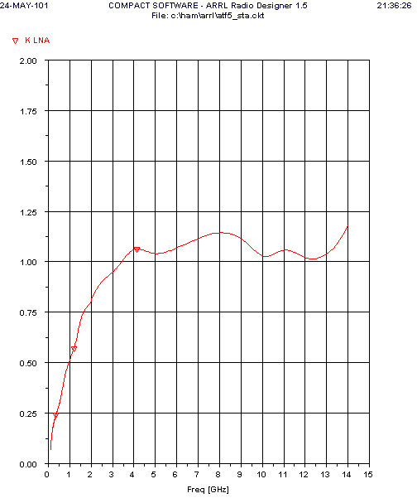
As you can see the transistor is potentially unstable below 3,5 GHz – this is a wild animal!

To increase stability some attenuation is put directly on the drain terminal. This can be in the form of a ferrite bead or a resistor. Resistors on the gate terminal will also improve stability, and must be placed after the UHF decoupling to avoid any impact on noise figure. Another stabilising technique is using just a little inductance in the source (1-2 mm of source lead).

DESIGNING

I have used a computer program ‘ARRL Radio Designer’ for designing the amplifiers. It runs under Window’s and is based on the professional Super-Compact circuit simulator program - at a fraction of the cost.
(Unfortunately ARRL has stopped selling this program – so get it ‘surplus’ if you can)

The design procedure is this : load s-parameters (from internet), run stability analysis and then increase stability with resistores and/or source feed-back as required. Next calculate input and output matching for optimum noise (a special feature of ‘ARRL Radio Designer’).

The program can now calculate gain, noise figure, stability, input VSWR and a lot of other parameters for the finished amplifier. After that it’s just to build the thing.

INPUT MATCHING

The input circuit transforms the 50 ohm antenna into the optimum generator impedance for the transistor.

Looking at a Smith-card we have to go from the center of the card to a point towards the perifery. The more transformation the more complex (and lossy) the input circuit. Unfortunately Fet transistors – at low UHF frequencies – have rather high impedances for optimum noise match, making it difficult to achieve the very low noise figure the device itself is capable of.

A great advantage of ATF-54143 is an optimum noise match close to the center of the Smith-card. On 1296 MHz just a 9 nH inductor in parallel with the input will do the trick! And with less transformation – we have less insertion loss and uncritical component values .

To give some low frequency cut-off the transformation is done by a series capacitor and a parallel inductor.

OUTPUT MATCHING

Similar to the input matching the output match transforms the 50 ohm output impedance into the load impedance for maximum gain (or max. output power depending on what you want).

Again transformation is done by a parallel inductor and a series capacitor.

BIAS

ATF-54143 works with a drain voltage of 2 to 4V. Maximum drain current is 120 mA. The noise figure is almost independent of drain current and (as you might expect) large signal handling improves with drain current.

I have selected 3V and 60 mA as bias. (-but with 10 ohm drain resistor I end up with 0.6V less voltage)

Being an enhancement mode device the transistor needs a positive voltage on the gate in order to draw drain current – typ. + 0,59V on the gate to give 60 mA drain current. If the gate is put to ground potential the current will drop to a few microamperes of leakage current. This is more like biasing a bipolar transistor !

Therefore we have the possibility to make a simple resistor bias as well as building an active bias. To show both principles, I have used the passive bias for the 1296 MHz amplifier and the active bias for the 432 MHz amplifier.

To test the bias circuit before using it, you can connect an ordinary NPN transistor (BC547) instead of the HEMT (Vg on base, Vd on collector). If everything works OK, you should be able to bias the collector to 60 mA at 3V with active bias (but only 30 mA 4V using passive bias due to different DC caracteristic)

432 MHz AMPLIFIER Measured at 432 MHz : NF 0.26 dB and Gain 23.2 dB

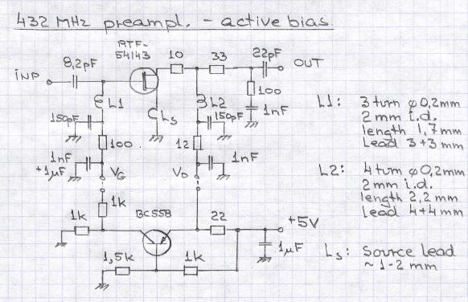

1296 MHz AMPLIFIER Measured at 1296 MHz : NF 0.39 dB and Gain 18.4 dB

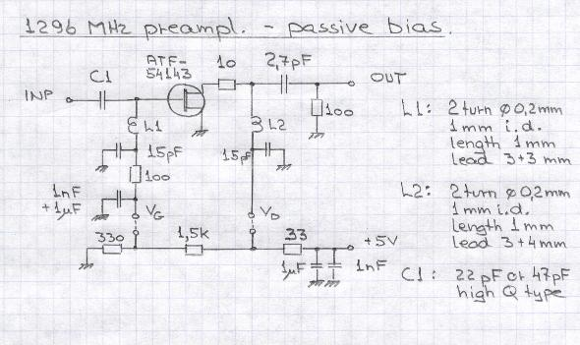

BUILDING

Prototypes have been build on breadboard – a piece of 0.8 mm epoxy board (FR4). I have cut out ‘islands’ about 2 x 2 mm big for mounting the components. The SMA connectors are soldered to copper ‘ground’. I have used SMD components around the UHF signal and decoupling path.

432 MHz LAYOUT – active bias circuit on different PCB

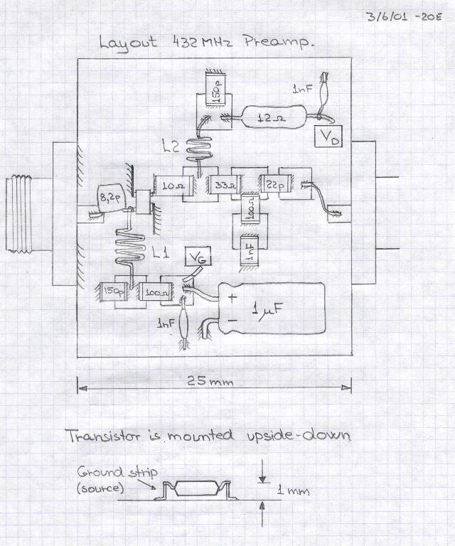
Simulation shows the 432 MHz amplifier to be more stable with some source self inductance. This is done by mounting the transistor upside-down on two small ground strips each 1 mm high by 4 mm long. These strips add about 0.5 nH to the source. The gate (and drain) is in free air, so there is no loss due to the epoxy PCB.

1296 MHz LAYOUT - including bias circuit.

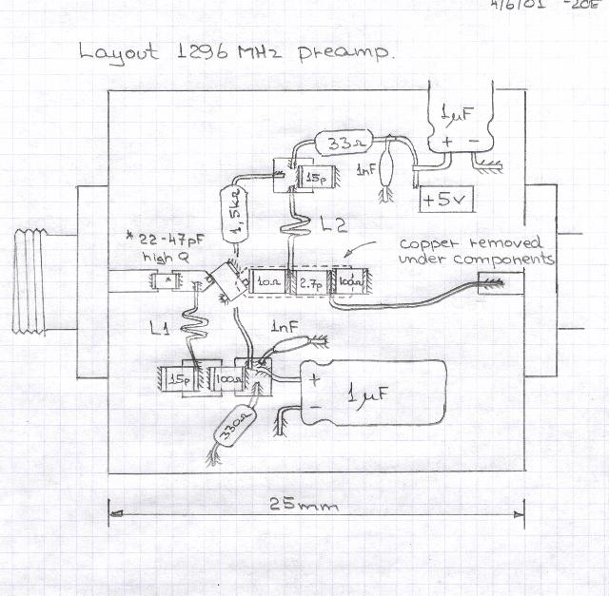

The 1296 MHz amplifier has the transistor mounted in ‘normal’ fashion. The gate ‘island’ should be as small as possible to reduce loss from the PCB and it must be cut in the shape of an arrowhead towards the gate terminal. On the drain side I have removed copper in a long trench and just soldered the component terminals together.

Good luck .......

Copy from here. More here.

