Review of IC-9700 for Weak Signal Digital Modes
by Rex Moncur VK7MO
Note 1: This review is primarily based on a single radio. In order to establish that the stability issues raised in this review are not related only to this radio a second radio has been tested (see section 2.5 ). This second radio shows similar problems with instability for digital modes.
Note 2: As this review is focussed on weak signal digital modes one should not extrapolate the findings to other modes. Rob Sherwood, NC0B, has done tests on the stability issues with SSB which are available at following web site. He reports drift of 50 Hz on SSB on 70 cm and states this is definitely a problem.
http://www.dj0ip.de/sherwood-forest/vhf-uhf-xcvr-tests/icom-ic-9700/

Note 3: My purpose in raising the issue of stability is not in any way to be negative about the radio but to encourage ICOM to come up with a GPSDO locked solution, as we were all led to expect when we saw the 10 MHz reference input on the brochure. Such a solution will make this a flagship radio for VHF and microwave weak signal work. My assessment of the radio is a very positive one and I love it. It has many great features and advantages over my older ICOM rigs.
Pros:
1. An essentially flat passband from 100 Hz to 3000 Hz that is a useful advantage for wide bandwidth digital modes such as MSK144, ISCAT-B and QRA64-E.
2. Internal soundcard, PTT and CAT control all work over a single USB connection which avoids many cables and additional boxes for portable operation, the problem of using modern computers with combo ports (no separate line-in line-out), and reduces hum loops.
3. 1 Hz CAT control stepping for Doppler Correction on EME.
4. I nice feature is the Max power limit which can be set to say 1 watt (or lower) to feed transverters.
5. No ALC overshoot. (Some operators have reported tripping of Sold State PAs - this is not due to overshoot but rather high SWR caused by transmission prior to the antenna relay changing over. (See note Section 6 below on tripping)
6. A generally very nice radio to use.
Cons:
1. It is not GPSDO lockable - despite having a 10 MHz reference input. This is used for calibration only. This is unlike the IC-7610 which does provide for GPSDO locking of the radio.
2. The stability is not satisfactory for most digital modes - for example up to 30 Hz drift on 144 MHz and 300 Hz on 1296 MHz within 4 minutes each time the fan comes on.
Nice-to-have:
1. It is useful when working short duration propagation modes such as aircraft and meteor scatter if when working digital you can pick up the mic and work SSB when the signal peaks. It is possible to run both by setting the IC-9700 parameters as follows:
Menu > Set > Connectors > Mod Input > Data Mod :- Mic,USB
However, this method has the problem that any inadvertent mic audio will be imposed on the digital audio. It is possible to overcome this by a small modification to the mic as shown at:
http://hflink.com/icom/microphone/hm36/
2. It would be useful to have options to extend the TX delay from the present max of 30 ms to 100 ms and 150 ms to cover the change-over of waveguide switches when the radio is used as an IF for microwave operations.
1. PASSBAND
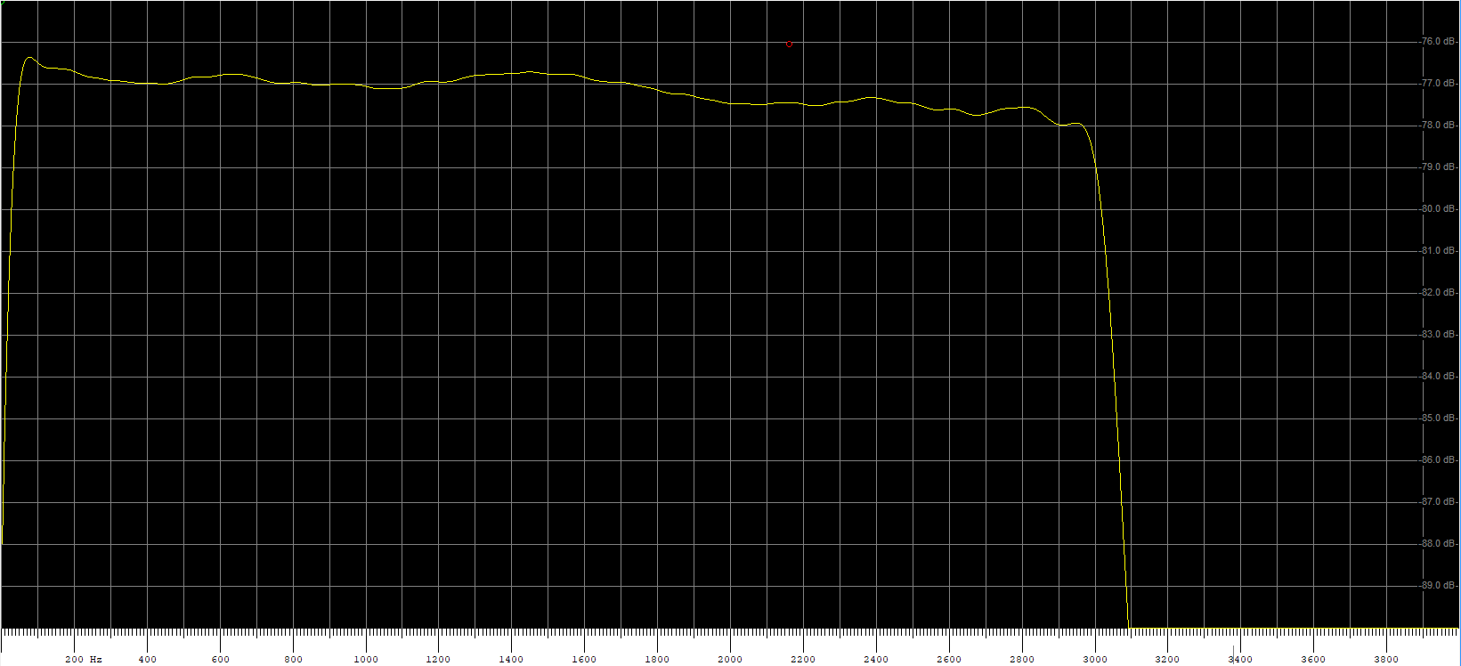
Fig 1: Passband for Filter 1 default setting of 3 KHz and "sharp". The vertical scale is 1 dB as indicated by the horizontal lines. The horizontal scale is 0 to 4 kHz.
Fig 1 shows that over the range 400 Hz to 2.8 kHz the passband is within +/- 0.5 dB which is excellent for the wider digital modes such as MSK144, ISCAT and QRA64-E. In case one is tempted to make it wider, Fig 2 shows what happens if you increase the passband to the maximum of 3.6 kHz. Note that if you use the "soft" setting on the filter the response drops off significantly before each end and thus only the "sharp" filter is recommended.
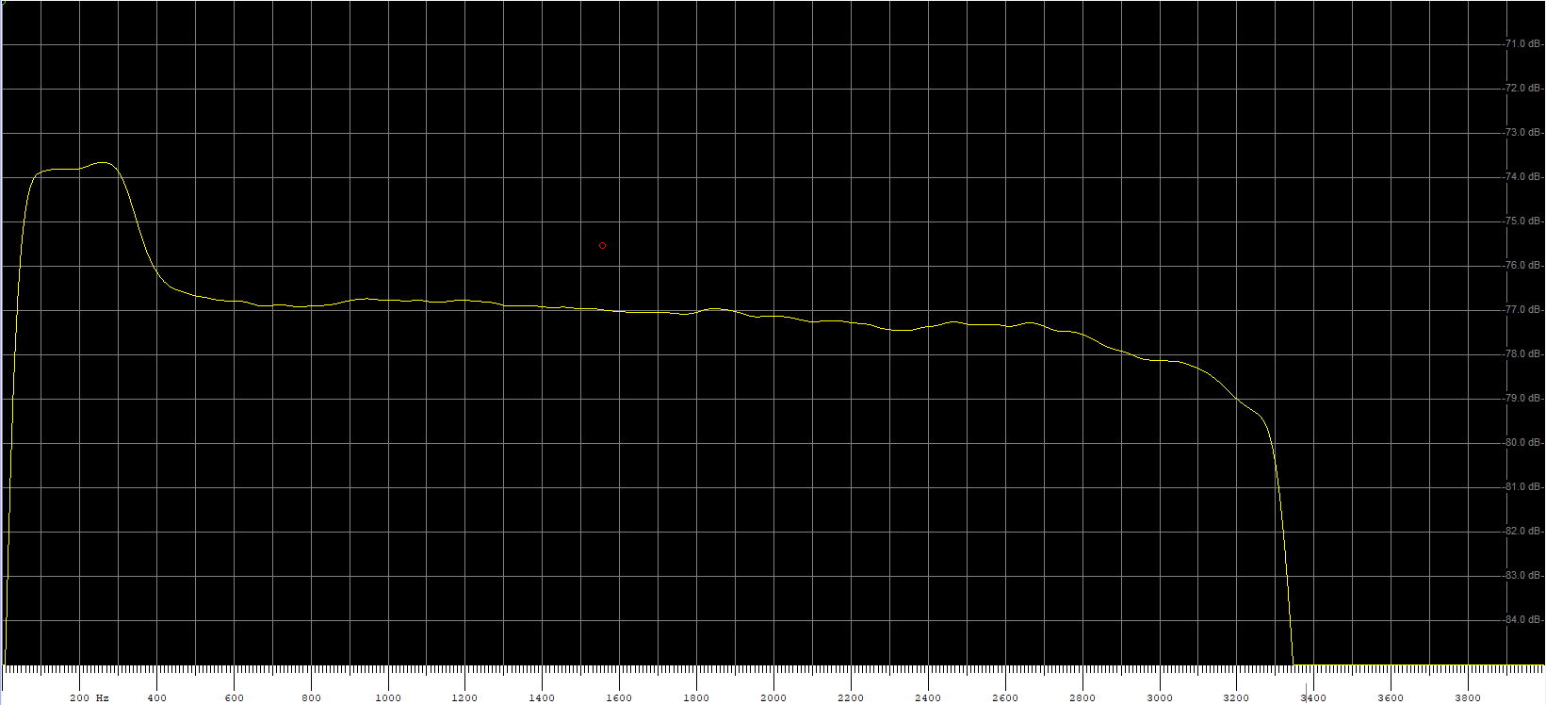
Fig 2: Passband increased to the maximum of 3.6 kHz
Fig 2 shows a 2 to 3 dB hump between 100 Hz and 400 Hz and while the passband does extend beyond 3 kHz the level is essentially no better at 3 kHz. Accordingly it is recommended that one keep the passband at the default value of 3 kHz.

2. STABILITY TESTS
2.1 Test Procedure
The test procedure for the stability tests below is based on the IC-9700 listening to a GPSDO locked signal source with an accuracy of 3 parts in 10^10. The IC-9700 is tuned 1 kHz below this to produce a 1 kHz tone which is fed to Spectrum Lab with a resolution of better than 1 Hz. Thus in most cases the drift that is seen is during the RX period. When the IC-9700 transmits there is a gap and thus the drift is measured between successive transmissions.
To check the actual drift during transmission, one test was done (Fig 9) by listening to the transmissions with a separate GPSDO locked IC-9100 and this shows the drift on TX is similar to what is seen by looking at the gap between transmissions. Figs 17 and 18 are also based on receiving with the GPSDO locked IC-9100.
2.2 Examples of Drift
Fig 3 below is an example of the frequency stability on 144 MHz with the rig operating in a home environment and the case temperature varying by about 10 Degrees C.
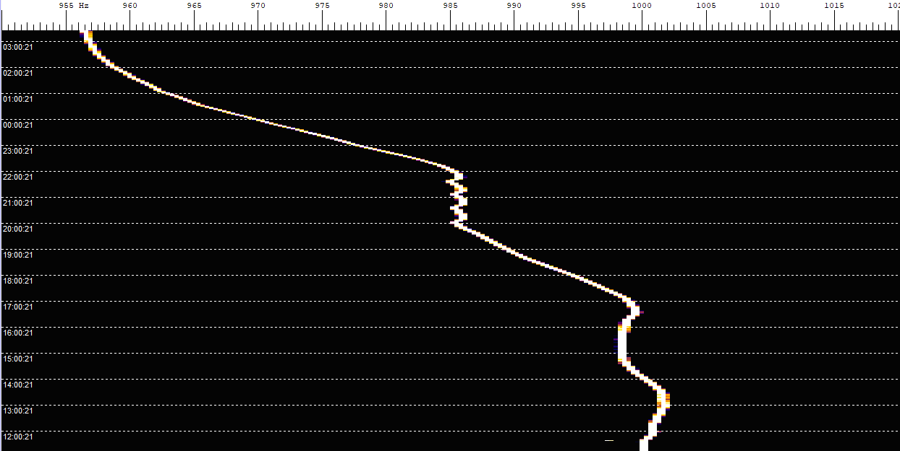
Fig 3: Frequency variation on 2 metres with a temperature variation of about 10 Degrees C over about 16 hours while not transmitting. The odd looking small ripple is due to the airconditioning system turning on and off and is not significant. Only the broad trend is relevant to the radio. The total frequency variation in a typcial home environment is around 40 Hz.
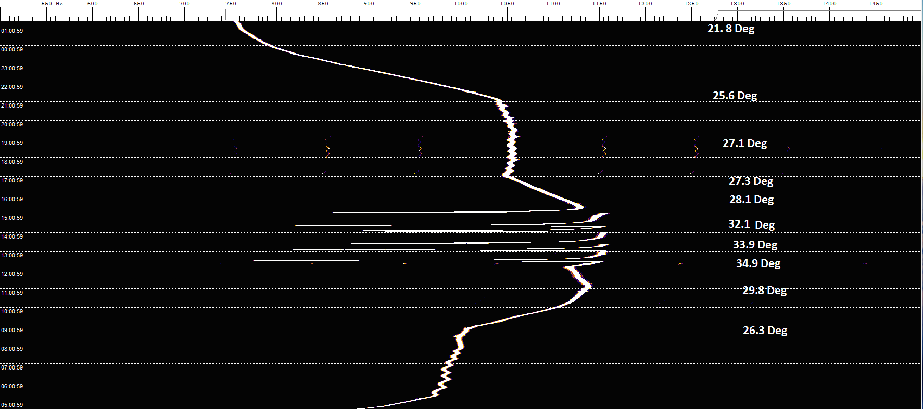
Fig 4: A similar test to Fig 3 on 1296 MHz.
Fig 4 shows frequency variations of over 300 Hz at 1296 MHz. The jumps occur when the temperature rises above about 30 degrees C and are related to the cooling fan turning on and off.
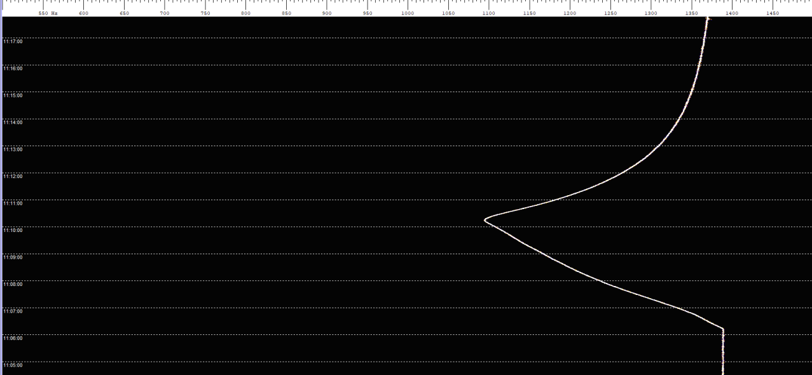
Fig 5: Example of a frequency jump at 23 cm scaled up. Vertical scale is indicated by the horizontal lines and is one 1 minute per division. Unless one is transmitting the case temperature needs to be above 30 degrees C to cause the fan to come on and produce the jumps.
As seen in Fig 5 the jumps go low in frequency by around 300 Hz over about 4 minutes and exponentially return to the original frequency over another 10 minutes or so. I was able to correlate the downward jump in frequency with the fan turning on. As this and all other graphs (other than Figs 9, 17 & 18) relate to receiving; a drop in the graphed frequency implies that the frequency of the radio's oscillator increased.
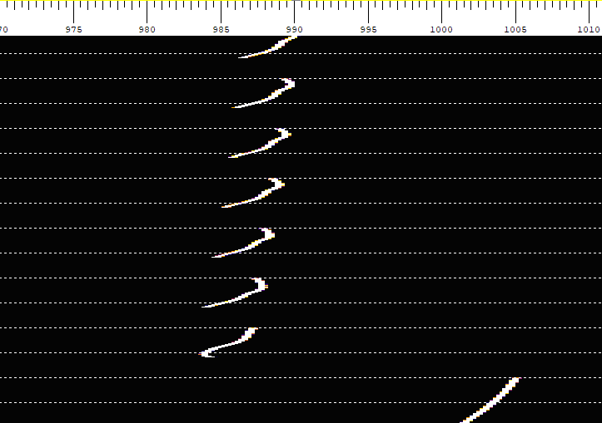
Fig 6: Shows frequency variations on 2 metres when transmitting the digital mode QRA64 C. The vertical scale is indicated by the horizontal lines which are 1 minute periods. The data is for the receive period after the completion of each transmission.
The bottom of Fig 6 starts at the time of a first transmission at 50 watts on 2 metres. It is seen that there is a frequency change of around 20 Hz on the first transmission but after that the changes reduce to around 4 Hz. The fan comes on only during transmission unless the case temperature is above 30 deg C. The first transmission thus causes the largest jump until the fan comes on consistently during transmissions and the drift reduces.
It is clear that the key stability problem relates to the fan turning on and off and thus one could expect a significant improvement if the fan ran all the time.
2.3 Comparison with a GPSDO locked IC9100
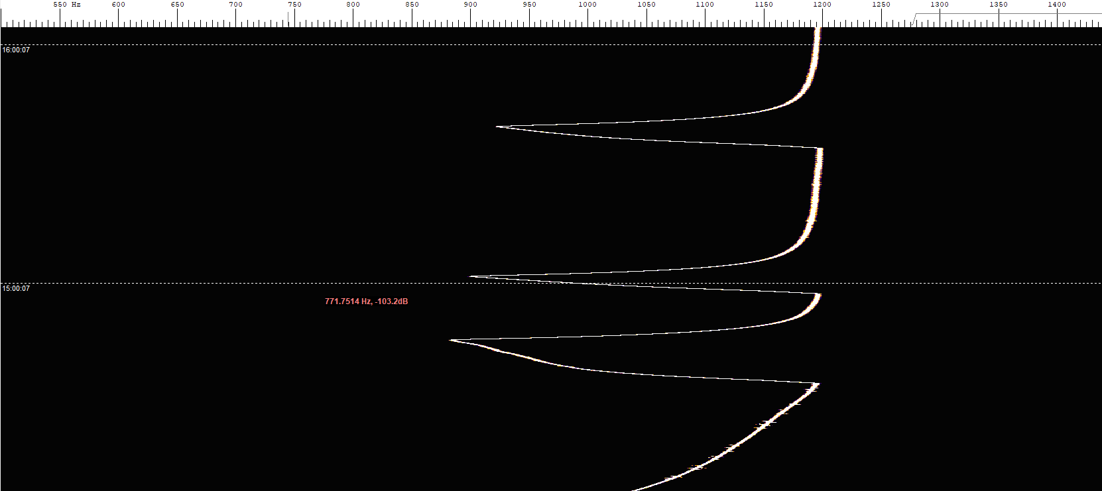
Fig 7: IC-9700 at 23 cm receiving from a GPSDO signal source. RX only but with case temperature above 30 degrees so the fan turns on and off.
Fig 8: The same test at the same time and with the same scale as for Fig 7. But in this case the receiver is an IC9100 GPSDO locked with a VK3HZ unit.
As can be seen by comparing Figs 7 and 8, GPSDO locking provides a dramatic improvement in stability.
2.4 Test to confirm drift during transmission
The drift during transmission as measured on a GPSDO locked IC-9100 (Fig 9 ) is compared with that on the IC-9700 during the RX period (Fig 10). These tests are at 144 MHz with a transmitter power of 20 watts. There was a 10 minute break in transmission to show the increase in drift during the first period of transmission.
Fig 9: Drift on 2 metres with the IC-9700 transmitting as received on the GPSDO locked IC-9100. In this case transmission was stopped for 10 minutes to show a frequency variation of around 20 Hz on the first transmission due to the Fan coming on. If you look carefully at the start of the period at 13:50 there are a few seconds where it is stable before the fan comes on.

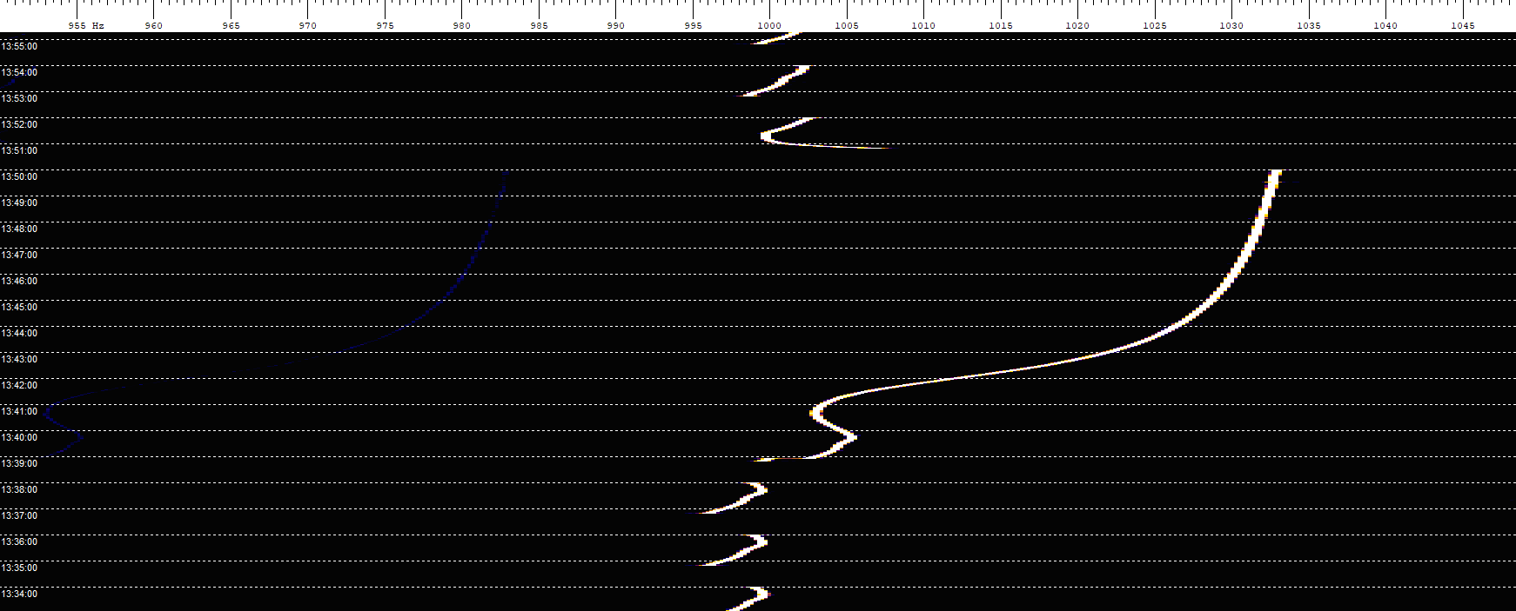
Fig 10: Drift on the IC-9700 at 2 metres during the RX period between transmissions. It is seen that when transmission is stopped for the 10 minute period for 13:39 to 13:50 the frequency increases by around 30 Hz which relates to the Fan not being on.
As shown in Fig 9 and Fig 10 the drift is around 4 Hz providing one transmits regularly every second period (1 minute) on QRA64. However after a 10 minute break the effect of the fan going off and then on again increases the drift to around 30 Hz. The tests in both Fig 9 and Fig 10 show similar amounts of drift by both methods.
2.5 Testing a second Radio
Fig 11 shows a test of a second radio running 20 watts FM for one minute on 2 metres. The drift is around 20 Hz during the transmission period of one minute. The overall drift on receive is around 25 Hz. Again, that the drift is caused by the fan turning on and off. Overall I conclude that there is no significant difference between the stability performances of two radios. It is noted that as more hams test the stability they are getting similar results.
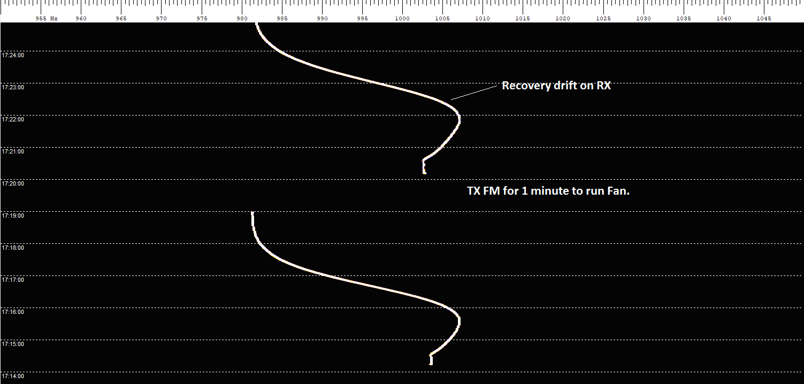
Fig 11: Drift tests on 2 metres running 20 watts FM followed by monitoring the recovery on USB-D. The vertical scale is 1 minute divisions as indicated by the horizontal lines.
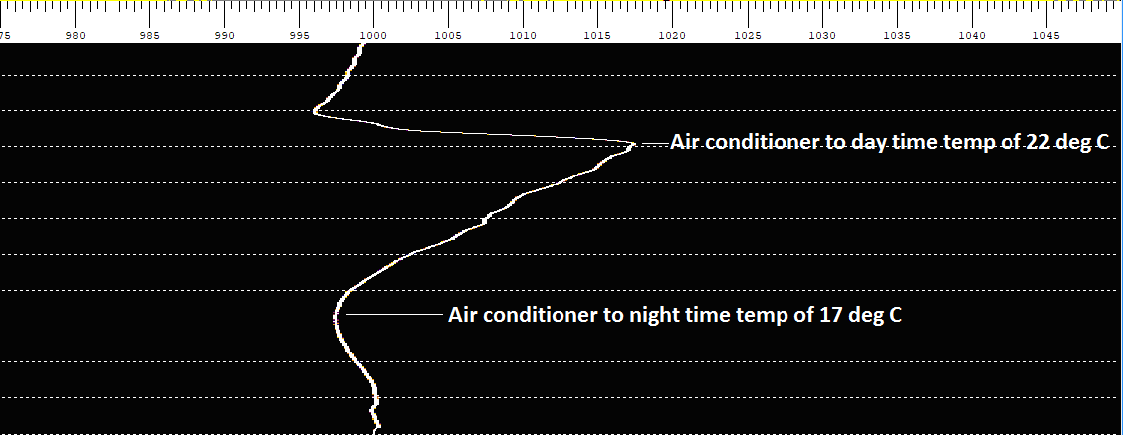
Fig 12: Shows long term drift at 2 metres in a typical home environment - the vertical scale is 1 hour per division as indicated by the horizontal lines. While the air conditioner thermostat showed a change of 5 degrees the air temperature at the radio is estimated to change by around 10 deg C. The radio fan does not come on for this test.
Fig 13 shows the drift on 432 MHz running QRA64. Again it is seen that the first TX period produces the largest drift of around 70 Hz and this drops to around 15 Hz on repeated transmissions. Fig 14 shows the same test but with the power reduced to 1 Watt. While the overall drift during the QRA sequence is similar, the 1 Watt example is quite different in nature and in fact produces both a positive and negative drift of around 15 Hz during each RX period which would be even more difficult to decode. Interestingly the large jump in the first transmission is no longer present. One can speculate that by running at 50 watts the first transmission is more likely to fail but by running at 1 watt the remaining receptions are more likely to fail.
Fig 13: Drift on 432 MHz with Power Output set to 50 watts. Vertical scale is 1 minute as shown by the horizontal lines.
Fig 14: Drift on 432 MHz with Power Output reduced to 1 watt. Vertical scale in 1 minute as shown by horizontal lines.
2.6 Operation of the Fan
It is clear that the dominant cause of the drift is the fan turning on and off. What is not clear are the circumstances under which the fan turns on. What we can say about the fan is the following:
- It does turn on if the case temperature rises above 30 to 34 degrees C even without transmitting.
- On 2 meters and 70 cm it does turn on if you use digital modes even with very low power levels down to 1%.
- On 23 cm it appears to react differently in that even at 100% power the fan did not come on. This might indicate some temperature dependence.
- There is some evidence that the speed of the fan increases with higher power but I have not been able to make a positive determination that this is the case.
To get some idea of the benefits of running the fan full time I connected a vacuum cleaner to suck through the fan and give a continuous air flow. These results are at Fig 15 but show only a small improvement and are not conclusive.
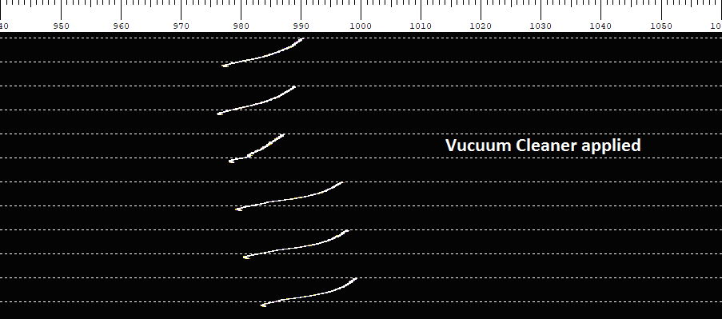
Fig 15: Test on 432 MHz running 50 watts QRA which compares to Fig 13 above. The vacuum cleaner was continued after it was applied and while the drift did reduce when it was applied, in subsequent transmissions it increased to almost the same level.
2.7 Does it meet Specification?
The stability specification is 0.5 ppm from -10 to 60 degrees C. This implies a max drift at follows:
2 metres 72 Hz
70 cm 216 Hz
23 cm 648 Hz

To date I have not seen drift outside these limits but I have seen drift of around half of these values over a 10 degree temperature range and this does not give one confidence that it could meet the specifications over the 70 degree range it is specified. But without a controlled temperature chamber it is not possible to test this.
Perhaps more important is to ask is the radio fit for purpose. The ICOM USA web site about the IC-9700 starts off with the statement:
"Built with the VHF/UHF weak signal operator in mind"
There are strong indications that it is intended for weak signal digital modes as it includes a USB-D setting for digital modes. The brochure also shows it has a "10 MHz reference input" which most people assume means that it can be locked to a GPSDO. It is probably sufficiently stable for fast digital modes such as ISCAT and MSK144. But it is not sufficiently stable for slow weak signal digital modes such as WSPR, JT65 and QRA64 on the sub-modes normally used on the frequencies that apply to this radio.

3. CALIBRATION FACILITY
The calibration facility has both a coarse and fine adjustment and this can allow calibrations to better than 1 Hz at 2 metres. But in addition to being able to apply an accurate 10 MHz signal to the Reference Input socket this method does require an accurate and stable GPSDO locked source and a set-up such as Spectrum lab to adjust it.
There is also an Auto-Calibrate facility which makes the process much simpler as all you do is apply the 10 MHz reference and press the button to calibrate it. The accuracy and repeatability of the Auto-Calibrate facility has been improved by about a factor of four with Firmware revision 1.06. However, there are still calibration errors of up to 1 Hz at 2 metres and 10 Hz at 1296. While this is acceptable for most circumstances these errors do have implications for proposals to continually apply auto-calibration to correct the radio for drift. Fig 16 shows what happens to the frequency during the process of auto-calibration. It is seen that not only does auto-calibration produce long term jumps the process causes short-term jumps (of less than a second) as it runs through a number of steps which move the frequency up to 50 Hz. For digital modes this combination of random jumps would make it unusable if applied continuously to reduce drift.
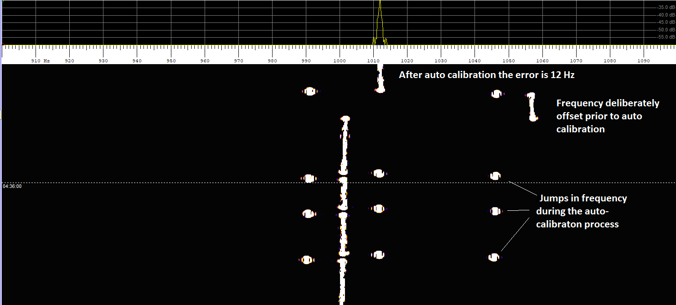
Fig 16: This shows around a 30 second period during which auto-calibration is applied at intervals of 5 to 10 seconds. It shows the process of auto-calibration produces jumps of up to 50 Hz.
4. TESTS ON WSPR
Tests transmitting WSPR at 50 watts on 2 metres show no decodes at all if running at a 10% duty cycle while it does decode (even if intermittently) if the WSPR duty cycle is increased to 50%. In effect by running at 10% duty cycle we let the fan stop for an extended period thus when it does transmit after an extended period, this is equivalent to a first transmission as reported above. VK3WRE reports that his IC9700 has achieved decodes with 15% duty cycle, but that at this level decoding is intermittent.
To give some idea of the impact of running the fan full time WSPR tests were conducted on 432 MHz between the IC-9700 (transmitting) and my GPSDO locked IC-9100. Fig 17 shows the results where the WSPR duty cycle is 10% and there is a break of several periods between transmissions. The fan stops during the break and starts a few seconds after each transmission starts. The total drift in these examples is 35 Hz and 70 Hz and in neither case did WSPR decode. Fig 18 starts after a similar break and then runs at 100% duty cycle. On the first period it gives a similar result with no decode. The fan starts with the first transmission and then runs continuously. In subsequent periods 10:04 and 10:06 the drift is significantly diminished and both decoded correctly.
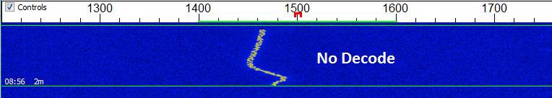
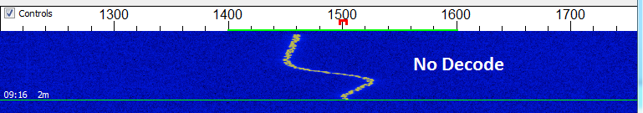
Fig 17: WSPR signal with 10% duty cycle
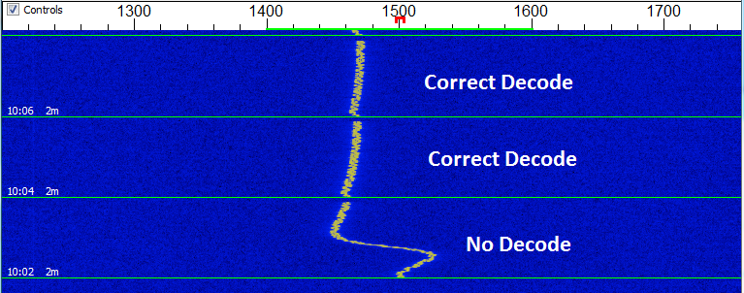
Fig 18: WSPR signal with 100% duty cycle. The drift reduces to around 6 Hz in the second and third period and correct decoding occurs
It is seen that running the fan full-time reduces the drift by a factor of around 10 times after the first period so it seems worth making this modification.
5. TESTS ON QRA64 at 1296 MHz
Initial tests with VK7PD who has a GPSDO locked TS2000, showed no decodes at all on QRA64C as normally used on 1296 MHz. We then tried QRA64D which has twice the tone spacing - VK7PD started to achieve decodes but it took several transmissions before VK7MO achieved decodes.
6. TRIPPING OUT OF SSPAs
This can be resolved by extending the delay time prior to transmission so as to ensure the SSPA Antenna relay has changed over. See Section 8 Set mode of the basic manual as below.
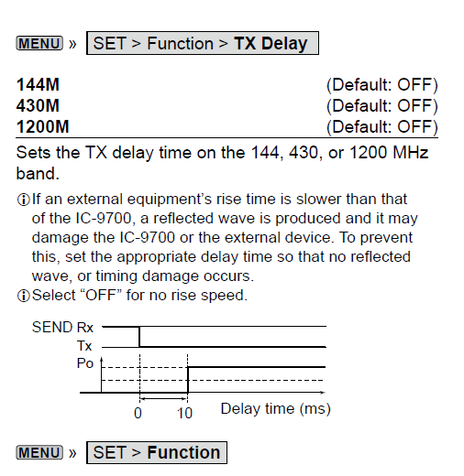

The maximum delay of 30 ms is generally a safe option. However, for those running QRO with larger and slower antenna relays, or using the radio to as an IF for microwaves with a waveguide switch it might be necessary to increase it beyond the 30 ms. A suggestion by PA1TK is as follows:
PA1TK Suggestion:
No overshoot or tripping both on my IC7300 of IC9700. The internal max 30ms is too fast in my opinion.
Simple solution:
For the IC9700 made a small box with a 8pin microphone (male) connector, wired with ptt lines to another box where I can choice 144/432/1296 amplifiers.
PTT lines come delayed back (some 150 ms) to the 8pin microphone box and ic7300/ic9700.
This makes sure that the amplifiers are running (preamp off, coax on, small delay: bias on) before any rf drive is entering

If you are running WSJT it includes as default, a 200 ms delay before tones are sent after PTT, and this is sufficient for even slow waveguide switches. But of course you cannot rely on this if you then pick up the mike and go to SSB.

7. POSSIBLE SOLUTIONS
It is clear that a significant improvement in short-term stability could be achieved if the fan was connected to run full time. And this is certainly worth testing.
WA7FWF has tested a solution that significantly reduced the drift by running the fan at half speed at below:
Rex,
6.8v Zener across Q2881, so yes the fan runs all the time now at about half speed, the radio can still go to full speed if it wants to, during the testing I did not notice it going any faster than the half speed but it's hard to tell as my frequency counter fan makes more noise.

73 Kevin WA7FWF

Stephen, G8LYB, has tested the above modification and shown significant improvements in stability as listed below: He does, however, see this as a temporary work around and states "I do hope that ICOM is able to implement a frequency disciplining facility".

144MHz 20% power approx 1Hz variation during the transmit period
144MHz 100% power approx 1-2Hz variation during the transmit period
432MHz 20% power approx 2Hz variation during the transmit period
432MHz 100% power approx 5-6Hz variation during the transmit period
1296Hz 100% power approx 1-2Hz variation during the transmit period
Another solution that has been considered is a software fix that continuously up-dates the auto-calibration function against the external reference. Unfortunately the errors in auto-calibration discussed above suggest that this would introduce random frequency jumps. For this approach to work on all digital modes the accuracy of the auto-calibration function would have to be improved, so that jumps are less than a Hz on all bands up to 23 cm.
In my opinion the only reliable solution is to make provision for the radio to be locked to a GPSDO and this is likely to require a hardware fix along the lines that has been successfully applied to the IC-910 by the author and the IC-9100 and a wide range of radios by VK3HZ . Much of what is required is already included with the existing calibration facility but it would require an additional board to be developed and added by hams to the radio. Some people have correctly pointed out that running an SDR radio at 432 MHz puts very stringent constraints on the jitter performance of the master oscillator and circuitry associated with the oscillator. I have discussed these issues with Glen, VK1XX, who is a designer of SDR radios. While he agrees entirely with these concerns he points out that in terms of GPSDO locking we are only interested in the voltage that controls the oscillator and that this can readily be integrated with a long time constant so as to have minimal affect on the performance of the SDR. Most hams use high quality double oven GPSDOs that were originally designed for CDMA telephone systems and these should have little impact of the performance of the radio. Hopefully ICOM can come up with an innovative solution such as board that can be added by hams and not void the warranty for those who require GPSDO level stability.
8. A WARNING ABOUT MODIFICATIONS
There is the risk that even simple modifications will void your 5 year warranty.
VK5KK has found that the radio uses JIS (Japan Industry Standard) screws. They look like Philips head screws but you can damage them if you try to use a Phillips head screwdriver. So if you propose to open the case of the radio make sure you have a set of JIS screw drivers. VA7OJ advises that a JIS #2 screwdriver is required.
9. CONCLUSIONS
While the IC-9700 is a major advance and an exciting new radio it is not suitable in its current form for weak signal digital modes. While the short-term stability will be improved by running the fan continuously (or at half speed) this will do little to help the long term stability. The author considers that with the increasing trend to weak signal digital modes, GPSDO locking is essential for any new all-mode radio at VHF and above that is aimed at the weak signal operator.
=====

