New 24 GHz EME World Record between VK7MO and G3WDG
17403 km on 5 March 2014

Rather than plan for the lowest spreading and degradation (as for previous failed attempts) we compromised by accepting higher spreading (175 Hz) and degradation (1.2 dB) so as to find a time when the elevations between the stations were near maximum (21 degrees total) to reduce atmospheric losses and also give a longer common window to provide more time for averaging. In addition VK7MO operated from Mt Wellington at 1270 metres to further reduce the atmospheric absorption losses. This strategy proved successful even though signals were marginal and it took over an hour to complete the QSO.

VK7MO’s Operating location on Mt Wellington (photo from earlier test)

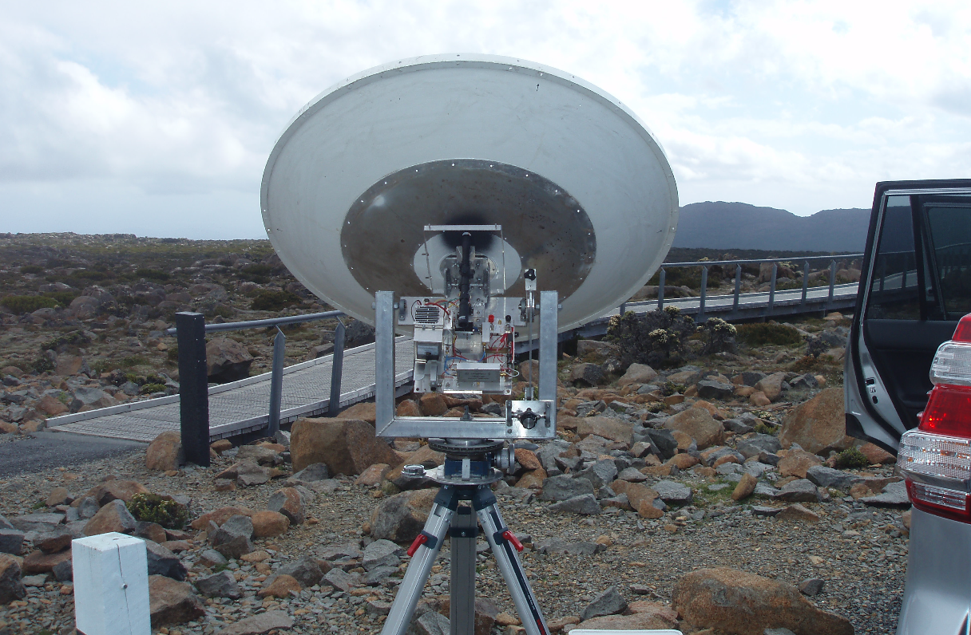

Equipment
G3WDG ran 10 watts to 3 metre dish and VK7MO 10 watts to a 1.14 metre dish. G3WDG’s transverter was GPS locked and he monitored the performance of his IF with a GPS derived 2000 Hz tone at 24048.227 MHz to ensure he was correctly tuned. VK7MO’s system is fully GPS locked and full Doppler correction was done at his end. Overall frequency accuracy is estimated at better than 10 Hz.

VK7MO was unable to use Moon noise for tracking – as his broadband detector was jumping to the same order as the Moon-noise. This could have been the result of other signals within the wide band-pass of the detector resulting from many hundreds of KW for TV and FM stations on the mountain or due to buffeting of the dish in the wind.

Conditions
At Hobart Airport, near VK7MO’s site, the 12:00 Z radiosonde data (an hour or so after the QSO) showed a PW of 12.3 mm and as seen at Appendix C most of the water vapour was concentrated in the lower 2000 metres and thus the effective PW at 1270 metres is likely to be much lower. VK7MO noted that signals changed from being present to nothing at all each time the moon was covered by cloud. It is suspected that the cloud was cumulous or cumulonimbus. At the average 10 degrees elevation 700 meters of cumulous cloud would reduce system performance by 0.7 dB and cumulonimbus around 5 dB (VK7MO spreadsheet based on ITU recommendation P.676-9). The air temperature on Mt Wellington during the QSO was around 2 degrees C with the wind gusting to 35 km/hr – not at all pleasant to be out on the top of a mountain in the dark for several hours as alignment of the dish required VK7MO to work outside for the full time.

The closest radiosonde station to G3WDG is Nottingham which did not run a 12:00Z flight. The average PW for the 00:00z flights either side of the QSO was 12.2 mm. G3WDG noted that there were no clouds at his end at the start and had the impression that during the QSO it was clear or just some high cloud. The temperature was 1 to 2 degrees.

Moonsked Data
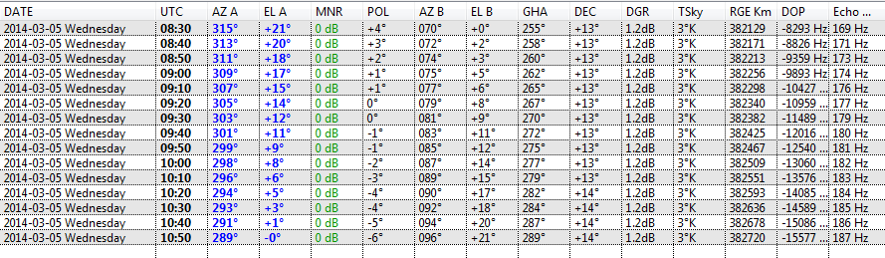

The Moonsked data shows that the total elevation for both stations is around 21 degrees and that over the period of the QSO the spreading ranged from 175 to 180 Hz and the degradation was 1.2 dB. Compared to earlier failed tests when spreading and degradation were lower the penalty would be 1 to 2 dB.

Test Results
The test results are at Appendices A and B. Overall VK7MO achieved 15 good syncs and G3WDG 12 good syncs. However, VK7MO gained 4 good single line decodes where-as G3WDG had to average over 6 periods to gain just one decode. The difference might be explained by the fact that G3WDG with the larger dish has to cope with more moon-noise but it could also be that VK7MO achieved his decodes when the Moon was at high elevation at his end and thus there was less absorption noise at his end. By the time that G3WDG had a similarly high elevation cloud at VK7MO’s end would have attenuated the signal. Good syncs were generally achieved with Signal to Noise levels around -19 or -20 dB and single line decodes at about -18 dB – suggesting that an improvement in system performance of just one or two dB could dramatically improve the prospects of a QSO.

As noted earlier VK7MO found that as soon as the Moon was obscured by cloud he lost the signal.

When syncs were considered to be valid VK7MO’s data showed an average error of -5.5 Hz and a standard deviation of 19 Hz. G3WDG’s data showed an average error of -38 Hz and a standard deviation of 18 Hz. The standard deviations are well within the 175 Hz spreading and are probably due to the difficulty of a maintaining G3WDG’s narrow dish exactly on the centre of the moon. The reasons for the difference in absolute frequency are not clear at this stage, but are not too bad for 24 GHz.

With the wider spreading single tones were more difficult to detect than on previous occasions. In this case the spreading was around 175 Hz reducing to around 90 Hz with G3WDG’s 3 metre dish. In practice this reduction is only valid if G3WDG can stay aligned to the exact centre of the moon so it is likely that the actual spreading is much wider than 90 Hz.

Lock-up on averaging
Both stations noted that WSJT stopped decoding after several averages and had to be restarted. VK7MO has also seen this on a long terrestrial run on WSJT 10. G3WDG thinks this might have been due changing the tolerance. This is something to watch and see if it re-occurs.

Conclusions
There are so many variables that it is difficult to draw firm conclusions but it is likely that the success of the QSO was due to:

- Choosing a time that maximised elevations (even at the expense of increased spreading and degradation)
- Using a mountain location to reduce absorption loss

There is evidence that cloud can be a major factor and that for such long paths through the atmosphere one needs clear sky at both ends -- although this effect does depend on cloud type.

With wider spreading single tones are much more difficult to see.

It seems that a system performance improvement of just one or two dB such as might be achieved with the proposed JT9W (possible improvement of 3 dB) or with increased power could dramatically improve the prospects of a QSO.

Appendix A
ALL.TXT File at VK7MO
Set parameters: MinW = C, Tol=100, WSJT version 9.5 r3033
Good DTs are highlighted in Green and show an average DF error (highlighted in Magenta) of -5.5 Hz with a standard deviation of 19.6 Hz – if we assume the Standard Deviation is the short-term error due to Moon alignment and the statistical variation due to spreading, then this dominates the much smaller average error due to tuning or the accuracy of the Doppler correction and thus we cannot say if there is any error due to tuning or Doppler correction based on this data.
UTC Date: 2014 Mar 05
---------------------
084800 Transmitting: JT4F @1270 Moon visible with no clouds nearby
084900 0 -20 -0.9 -105 4 *
085100 0 -20 5.4 15 9 *
085300 1 -20 2.3 85 15 *
085500 0 -21 1.5 -92 9 #
085700 0 -20 -0.8 53 7 *
085900 2 -19 3.9 96 4 *
090100 0 -21 -0.6 -123 4 *
090300 1 -19 1.6 66 7 # First Sign of 1270 Hz 38 Hz low as below 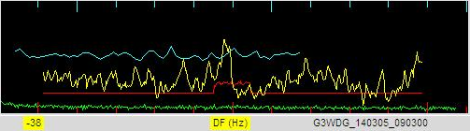
090500 0 -21 -1.3 158 13 # 1270 Hz on Frequency at 0 dF as per Yellow box
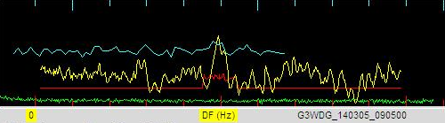
090700 0 -21 5.7 90 4 * 1270 now 57 Hz low
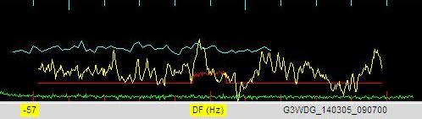
090900 1 -19 5.3 50 7 # No Evidence of 1270 or 1000 Hz
091100 1 -20 3.6 -136 4 # Evidence of 1000 Hz at -268 Hz which is only 2 Hz low
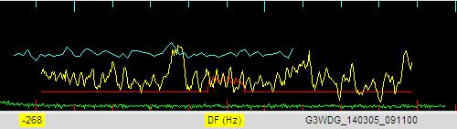
091206 Transmitting: JT4F G3WDG VK7MO QE37 VK7MO TXing calls and grid
091300 1 -20 0.9 103 7 #
091500 1 -20 1.1 7 7 * G3WDG started TXing calls and Grid
091700 2 -18 2.6 0 68 *
091900 0 -20 -0.1 -88 4 *
092100 2 -19 2.6 15 57 *
092100 2 2/2 VK7MO G3WDG IO92 ? 0 3 Decode on Average
092235 Transmitting: JT4F G3WDG VK7MO -18 VK7MO TXing calls and report 35 secs late
092300 3 -18 2.6 -2 61 * VK7MO G3WDG IO92 0 20 D Single line decode
092300 2 3/3 VK7MO G3WDG IO92 0 27
092500 1 -19 2.6 -18 57 * VK7MO G3WDG IO92 ? 0 1 F Single line decode
092500 2 4/4 VK7MO G3WDG IO92 0 26
092700 1 -19 2.7 -22 68 *
092700 2 5/5 VK7MO G3WDG IO92 1 25 Convolutional decode on Average
092900 3 -18 2.6 13 72 * VK7MO G3WDG IO92 ? 0 5 D Single line decode
092900 2 6/6 VK7MO G3WDG IO92 1 30
093100 0 -21 1.8 35 4 # Lost signal due to Cloud
093100 2 7/7 VK7MO G3WDG IO92 1 29
093100 0 -21 1.8 35 4
093100 2 6/6 VK7MO G3WDG IO92 1 30
093300 0 -20 4.5 -31 7 #
093300 2 7/7 VK7MO G3WDG IO92 1 28
093300 0 -20 4.5 -31 7
093300 2 6/6 VK7MO G3WDG IO92 1 30
093500 1 -20 -0.8 15 7
093500 2 6/6 VK7MO G3WDG IO92 1 30
Re-started WSJT when stopped decoding
UTC Date: 2014 Mar 05
---------------------
093700 1 -19 5.5 -553 4 #
093800 Transmitting: JT4F G3WDG VK7MO -18
093700 0 -21 1.3 -11 7 *
093900 0 -21 2.5 4 15 *
094100 1 -19 2.7 -18 7 *
094300 0 -21 1.3 -44 4 *
094500 0 -20 2.6 -11 22 *
094700 0 -21 -0.1 -31 9 #
094900 0 -21 0.7 18 4 *
095100 1 -19 -1.2 9 4 *
095300 0 -21 2.7 -11 4 * VK7MO G3WDG IO92 0 7 F Single line decode
095300 2 4/4 VK7MO G3WDG IO92 0 11
095500 2 -19 2.6 7 35 *
095500 2 5/5 VK7MO G3WDG IO92 0 23
095700 0 -21 3.4 -20 4 *
095700 2 6/6 VK7MO G3WDG IO92 0 16
095700 0 -21 3.4 -20 4
095700 2 5/5 VK7MO G3WDG IO92 0 23
095900 0 -20 4.0 -26 7 #
095900 2 6/6 VK7MO G3WDG IO92 0 15
100100 1 -20 2.6 -28 22 *
100100 2 6/6 VK7MO G3WDG IO92 0 23
100300 0 -21 4.2 -13 4 *
100300 2 7/7 VK7MO G3WDG IO92 0 18
100500 0 -21 4.7 -11 9 *
100500 2 7/7 VK7MO G3WDG IO92 0 23
100700 1 -20 2.4 9 37 #
100700 2 7/7 VK7MO G3WDG IO92 0 19
100900 0 -21 2.3 -94 7 #
101100 0 -21 -1.0 -13 7 #
101300 1 -20 5.3 44 13 #
101500 2 -18 2.6 20 61 # Moon became visible with break in cloud
101700 0 -20 2.7 -50 4 #
101900 2 -18 2.6 18 57 #
101900 2 3/3 VK7MO G3WDG R-19 ? 0 1 Decode on Average
102006 Transmitting: JT4F @1500 (RRR)
102100 0 -21 5.0 42 13 *
102100 2 4/4 VK7MO G3WDG R-19 ? 0 4 Confidence level improved despite wrong DT
102300 1 -20 -1.5 2 4 *
102300 2 5/5 VK7MO G3WDG R-19 ? 0 2
102400 Transmitting: JT4F @1700 (73)
102500 0 -20 -1.0 -28 7 #

Appendix B
ALL.TXT File at G3WDG
Set parameters: MinW = C, Tol=100

Full spreading ~175Hz: ant BW~0.5 of moon, so corrected full spread~90Hz Closest bin=E so MinW set 2 less at C per the manual. No single line decodes this end, so don’t know it this was the best choice.

Freq setting accuracy both ends ~10Hz. Rex initially reported DF=0. Rex’s 1270 looked about 25Hz low by eye here so froze DF at -25.

Ratein=Rateout=1.0000 (48kHz sampling set in Vista)

WSJT version 9.5 r3281

Good DTs are highlighted in Green and show an average DF error (highlighted in Magenta) of -37.9 Hz with a standard deviation of 17.6 Hz – thus as opposed to the VK7MO case the frequency error does appear to be significant cf the Standard Deviation.
Real Time results:
084100 Transmitting: JT4F @1270
084800 1 -20 3.4 490 7 * VK7MO started TXing 1270
084900 0 -21 0.4 492 4 *
085000 0 -21 3.3 492 9 *
085100 0 -21 -0.1 492 4 *
085200 0 -21 -1.0 492 4 *
085300 0 -21 -0.3 494 7 #
085400 0 -21 2.8 -433 15 #
085600 0 -21 5.0 494 4 #
085800 0 -21 0.7 -586 7 #
090000 0 -21 -0.9 -584 9 #
090200 0 -21 0.6 -584 11 *
090400 0 -21 3.4 295 13 #
090600 0 -21 4.2 508 11 #
090800 0 -21 2.5 492 4 *
091000 0 -21 5.5 497 9 # First sign of convincing 1270 tone
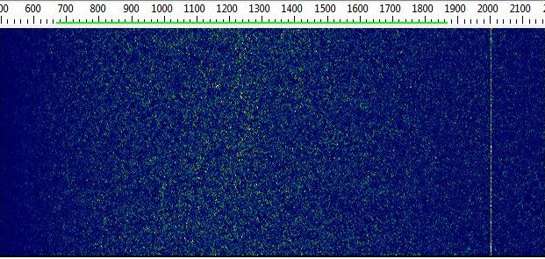
1270 tone from VK7MO – note narrow tone at 2000Hz is locally generated marker signal

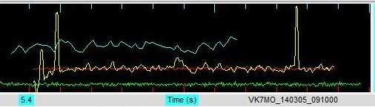
1270 tone from VK7MO (averaged spectrum)

091106 Transmitting: JT4F @1000
091200 1 -20 -1.2 24 7 # VK7MO TXing Calls and grid
091300 Transmitting: JT4F VK7MO G3WDG IO92
091310 Transmitting: JT4F @1000 changed my mind !
091400 2 -19 2.5 -7 61 *
091500 Transmitting: JT4F VK7MO G3WDG IO92
091600 0 -20 2.9 35 9 #
091600 0 -20 2.9 35 9
091800 1 -20 2.5 -31 53 *
092000 0 -21 2.5 -18 22 *
092200 0 -21 -1.6 33 26 *
092200 0 -21 -1.6 33 26
092400 0 -21 -1.6 -55 9 #
092400 0 -21 -1.6 -55 9 VK7MO Txing Calls and report
092600 2 -19 2.4 -55 63 # Rex probably went to reports (reset averaging here)
092800 1 -19 2.4 -28 57 #
093000 0 -21 3.9 -48 15 *
093000 0 -21 3.9 -48 15
093200 0 -20 5.6 -101 13 #
093200 0 -20 5.6 -101 13
093400 0 -21 -1.1 37 9 #
093400 0 -21 -1.1 37 9
093600 0 -21 1.3 -24 9

Tried to reset DF freeze to ~-50Hz but prog seemed to stop decoding so restarted it

UTC Date: 2014 Mar 05
---------------------
093800 0 -21 -0.7 -116 22 #
093900 Transmitting: JT4F VK7MO G3WDG IO92
094000 0 -21 -0.1 -35 31 *
094000 0 -21 -0.1 -35 31
094200 0 -21 2.6 -15 24 # included in average
094400 0 -21 3.9 15 7 #
094400 0 -21 3.9 15 7
094600 1 -20 5.0 -109 9 *
094600 1 -20 5.0 -109 9
094800 0 -21 2.4 -48 37 # included in average
095000 1 -19 3.0 -138 9 #
095200 0 -21 -1.6 -50 9 #
095200 0 -21 -1.6 -50 9
095400 2 -19 2.4 -57 59 # included in average
095600 2 -18 2.5 -44 20 # included in average
095800 0 -20 0.7 -33 13 #
095800 0 -20 0.7 -33 13
100000 1 -19 5.4 39 13 *
100000 1 -19 5.4 39 13
100200 2 -18 2.5 -55 55 # included in average
100200 1 6/6 G3WDG VK7MO -18 ? 0 4 puzzled why this is 6, unless I included one other frame by mistake!
100300 Transmitting: JT4F VK7MO G3WDG R-19
100400 0 -20 4.2 -103 11 * stopped caring about rejecting bad frames at this point!!
100400 1 7/7 G3WDG VK7MO -18 ? 0 4
100600 0 -20 3.3 -133 7 #
100800 0 -21 3.0 -46 9 #
101000 0 -21 5.4 -48 11 *
101200 0 -21 2.5 -42 20 #
101400 0 -20 4.5 -59 18 #
101600 1 -20 2.5 -55 42 #
101600 1 13/13 G3WDG VK7MO -18 ? 0 5
101800 0 -21 1.3 -15 9 *
101800 0 -21 1.3 -15 9
101800 1 13/13 G3WDG VK7MO -18 ? 0 5
102000 0 -21 5.4 -44 13 #
102000 1 14/14 G3WDG VK7MO -18 ? 0 2

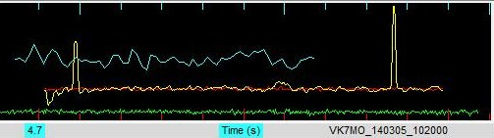
1500Hz tone from VK7MO signifying RRR at first tick to right of centre

102100 Transmitting: JT4F @1500 (RRR)
102000 0 -21 5.4 -44 13
102000 1 13/13 G3WDG VK7MO -18 ? 0 5
102200 0 -20 1.3 -79 13 #
102200 1 14/14 G3WDG VK7MO -18 ? 0 3
102302 Transmitting: JT4F @1700 (73)
102200 0 -20 1.3 -79 13
102200 1 13/13 G3WDG VK7MO -18 ? 0 5
102400 1 -20 -1.3 -2 20 #

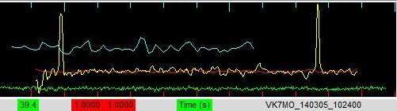
1700Hz tone from VK7MO signifying 73 (just discernible at second tick to right of centre)

102400 1 14/14 G3WDG VK7MO -18 ? 0 4
102600 2 -18 3.1 39 7 #
102700 1 -20 -1.0 -123 13 #
102800 1 -20 1.8 -55 9 *
102900 0 -21 -1.0 39 7 #

Post processing with as recall the same settings as used in real time
UTC Date: 2014 Mar 05
---------------------
090800 0 -21 4.5 -63 9 *
090800 0 -21 4.5 -63 9
091000 0 -21 0.4 44 7 *
091200 1 -20 -1.2 24 7 #
091200 1 -20 -1.2 24 7
091400 2 -19 2.5 -9 61 *
091600 0 -20 2.9 35 9 #
091600 0 -20 2.9 35 9
091800 1 -20 2.5 -31 57 *
092000 0 -21 2.5 -18 22 *
092200 0 -20 2.7 -98 26 #
092400 0 -21 -1.6 -55 9 #
092400 0 -21 -1.6 -55 9
092600 1 -19 2.4 -50 68 # included in average (advantage of hindsight!)
092800 1 -19 2.4 -28 55 # included in average
093000 0 -21 3.9 -48 18 *
093000 0 -21 3.9 -48 18
093200 0 -20 5.6 -101 13 #
093200 0 -20 5.6 -101 13
093400 0 -21 -1.1 37 9 #
093400 0 -21 -1.1 37 9
093600 0 -21 1.3 -24 9 # included this in average and got decode after 3!
093600 1 3/3 G3WDG VK7MO -18 ? 0 5

After this point did not reject many if any frames to see effect
093800 0 -20 -0.7 -116 9 #
093800 0 -20 -0.7 -116 9
093800 1 3/3 G3WDG VK7MO -18 ? 0 5
094000 0 -21 -0.1 -35 31 *
094000 1 4/4 G3WDG VK7MO -18 ? 0 1
094000 0 -21 -0.1 -35 31
094000 1 3/3 G3WDG VK7MO -18 ? 0 5
094200 0 -21 2.6 -15 26 #
094200 0 -21 2.6 -15 26
094200 1 3/3 G3WDG VK7MO -18 ? 0 5
094400 0 -21 3.9 15 7 #
094400 0 -21 3.9 15 7
094400 1 3/3 G3WDG VK7MO -18 ? 0 5
094600 1 -20 5.0 -109 9 *
094600 1 4/4 G3WDG VK7MO -18 ? 0 3
094600 1 -20 5.0 -109 9
094600 1 3/3 G3WDG VK7MO -18 ? 0 5
094800 0 -21 2.4 -48 31 #
094800 1 4/4 G3WDG VK7MO -18 0 12
095000 0 -20 2.4 -28 63 #
095000 1 5/5 G3WDG VK7MO -18 0 16
095200 0 -21 -1.6 -50 9 #
095200 1 6/6 G3WDG VK7MO -18 0 12
095200 0 -21 -1.6 -50 9
095200 1 5/5 G3WDG VK7MO -18 0 16
095400 2 -19 2.4 -50 44 #
095400 1 6/6 G3WDG VK7MO -18 0 13
095600 2 -18 2.5 -44 20 #
095600 1 7/7 G3WDG VK7MO -18 0 19
095800 0 -20 0.7 -33 13 #
095800 1 8/8 G3WDG VK7MO -18 0 16
095800 0 -20 0.7 -33 13
095800 1 7/7 G3WDG VK7MO -18 0 19
100000 1 -19 5.4 39 13 *
100000 1 8/8 G3WDG VK7MO -18 0 17
100000 1 -19 5.4 39 13
100000 1 7/7 G3WDG VK7MO -18 0 19
100200 2 -18 2.5 -50 77 #
100200 1 8/8 G3WDG VK7MO -18 0 14
100200 2 -18 2.5 -50 77
100200 1 7/7 G3WDG VK7MO -18 0 19
100400 0 -20 4.2 -103 11 *
100400 1 8/8 G3WDG VK7MO -18 0 18
100400 0 -20 4.2 -103 11
100400 1 7/7 G3WDG VK7MO -18 0 19
100600 0 -20 3.3 24 7 *
100600 1 8/8 G3WDG VK7MO -18 0 20
100800 0 -21 3.0 -46 9 #
100800 1 9/9 G3WDG VK7MO -18 0 21
101000 0 -21 5.4 -48 11 *
101000 1 10/10 G3WDG VK7MO -18 0 19
101000 0 -21 5.4 -48 11
101000 1 9/9 G3WDG VK7MO -18 0 21
101200 0 -21 2.5 -42 20 #
101200 1 10/10 G3WDG VK7MO -18 0 17
101200 0 -21 2.5 -42 20
101200 1 9/9 G3WDG VK7MO -18 0 21
101400 0 -20 4.5 -59 15 #
101400 1 10/10 G3WDG VK7MO -18 0 22
101600 0 -20 2.5 -50 39 #
101600 1 11/11 G3WDG VK7MO -18 0 26
101800 0 -21 1.3 -15 9 *
101800 1 12/12 G3WDG VK7MO -18 0 23
101800 0 -21 1.3 -15 9
101800 1 11/11 G3WDG VK7MO -18 0 26
102000 0 -21 5.4 -44 15 #
102000 1 12/12 G3WDG VK7MO -18 0 27
102000 0 -21 5.4 -44 15
102000 1 11/11 G3WDG VK7MO -18 0 26
102200 0 -20 1.3 -79 13 #
102200 1 12/12 G3WDG VK7MO -18 0 26
102200 0 -20 1.3 -79 13
102200 1 11/11 G3WDG VK7MO -18 0 26
102400 1 -20 -1.3 -2 20 #
102400 1 12/12 G3WDG VK7MO -18 0 19
102400 1 -20 -1.3 -2 20
102400 1 11/11 G3WDG VK7MO -18 0 26

Appendix C

94975 YMHB Hobart Airport Observations at 12Z 05 Mar 2014
-----------------------------------------------------------------------------
PRES HGHT TEMP DWPT RELH MIXR DRCT SKNT THTA THTE THTV
hPa m C C % g/kg deg knot K K K
-----------------------------------------------------------------------------
1018.0 27 12.6 5.6 62 5.63 200 15 284.3 300.2 285.3
1008.0 109 12.6 4.6 58 5.30 197 18 285.1 300.2 286.0
1000.0 175 12.0 5.0 62 5.50 195 20 285.1 300.8 286.1
982.0 326 10.6 4.7 67 5.49 200 20 285.2 300.9 286.2
956.0 549 8.6 4.3 74 5.47 209 20 285.4 301.0 286.3
945.0 645 8.0 0.0 57 4.07 213 19 285.7 297.5 286.4
925.0 821 6.8 -0.2 61 4.09 220 19 286.3 298.1 287.0
917.0 892 6.0 0.0 65 4.19 225 18 286.1 298.3 286.9
902.0 1027 5.8 -2.2 56 3.62 236 16 287.3 297.9 287.9
867.0 1349 3.0 -2.7 66 3.62 260 10 287.6 298.3 288.3
850.0 1510 1.6 -3.0 71 3.62 275 9 287.8 298.4 288.4
826.0 1740 -0.5 -3.0 83 3.73 271 8 288.0 298.9 288.6
819.0 1808 -0.8 -4.1 78 3.46 270 8 288.3 298.5 288.9
795.0 2046 -1.9 -7.9 64 2.66 251 10 289.6 297.6 290.1
780.0 2197 -2.7 -21.7 22 0.87 238 11 290.4 293.1 290.5
776.0 2238 -2.6 -23.9 18 0.72 235 11 290.9 293.3 291.0
741.0 2605 -1.5 -43.5 2 0.11 253 16 295.9 296.4 296.0
729.0 2735 -1.3 -32.3 7 0.35 259 18 297.5 298.8 297.6
710.0 2946 1.2 -36.8 4 0.23 270 20 302.6 303.4 302.6
700.0 3060 0.8 -35.2 5 0.28 275 22 303.3 304.3 303.4
694.0 3129 0.2 -34.7 5 0.29 275 22 303.4 304.5 303.5
674.0 3362 -1.9 -32.9 7 0.36 255 23 303.6 304.9 303.7
650.0 3652 0.2 -37.2 4 0.24 230 24 309.2 310.1 309.2
648.0 3676 0.4 -37.6 4 0.23 231 24 309.6 310.5 309.7
624.0 3978 -1.3 -22.3 19 1.03 242 24 311.1 314.6 311.3
606.0 4205 -3.0 -23.4 19 0.96 250 24 311.7 315.0 311.9
500.0 5700 -14.5 -30.5 24 0.61 255 38 315.3 317.5 315.4
447.0 6538 -21.7 -31.7 40 0.61 255 42 316.5 318.7 316.6
411.0 7153 -24.7 -39.7 24 0.30 255 44 320.3 321.4 320.4
400.0 7350 -26.5 -40.5 25 0.28 255 45 320.5 321.6 320.5
380.0 7708 -29.4 -43.0 25 0.23 255 50 321.4 322.3 321.4
300.0 9360 -42.7 -54.7 26 0.08 260 51 325.1 325.4 325.1
296.0 9450 -43.5 -55.5 25 0.07 260 51 325.2 325.5 325.2
266.0 10158 -49.9 -58.9 34 0.05 264 55 325.9 326.1 325.9
256.0 10406 -51.8 -60.1 36 0.05 265 56 326.8 327.0 326.8
250.0 10560 -52.9 -60.9 37 0.04 265 55 327.3 327.5 327.3
215.0 11513 -59.9 -66.9 40 0.02 268 58 330.8 330.9 330.9
200.0 11960 -62.9 -70.2 37 0.01 270 59 333.0 333.1 333.0
197.0 12053 -63.7 -70.9 37 0.01 270 59 333.2 333.2 333.2
184.0 12476 -62.5 -74.0 20 0.01 265 60 341.7 341.7 341.7
168.0 13040 -60.9 -78.1 9 0.01 261 56 353.3 353.4 353.3
150.0 13750 -59.3 -83.3 3 0.00 255 50 367.7 367.7 367.7
144.0 14006 -58.5 -84.0 2 0.00 250 44 373.5 373.5 373.5
135.0 14412 -57.1 -85.1 2 0.00 272 39 382.9 382.9 382.9
130.0 14648 -57.6 -85.2 2 0.00 285 36 386.1 386.2 386.1
107.0 15867 -60.0 -86.0 2 0.00 295 31 403.6 403.6 403.6
100.0 16290 -60.9 -86.2 2 0.00 285 37 409.8 409.8 409.8
88.3 17072 -55.7 -86.7 1 0.00 261 22 435.0 435.0 435.0
88.0 17094 -55.8 -86.8 1 0.00 260 22 435.2 435.3 435.2
84.0 17387 -57.2 -87.7 1 0.00 290 15 438.2 438.2 438.2
83.0 17463 -57.6 -88.0 1 0.00 300 16 439.0 439.0 439.0
79.4 17743 -58.9 -88.9 1 0.00 288 23 441.8 441.9 441.8
77.0 17937 -57.9 -88.5 1 0.00 280 28 447.9 447.9 447.9
73.0 18274 -56.0 -87.7 1 0.00 265 18 458.6 458.7 458.6
72.0 18361 -55.5 -87.5 1 0.00 280 14 461.5 461.5 461.5
71.9 18370 -55.5 -87.5 1 0.00 281 14 461.8 461.8 461.8
70.0 18540 -56.1 -88.1 1 0.00 305 16 464.0 464.0 464.0
68.0 18724 -57.8 -88.9 1 0.00 300 17 464.3 464.3 464.3
67.6 18761 -58.1 -89.1 1 0.00 294 17 464.3 464.4 464.4
64.0 19109 -56.7 -88.2 1 0.00 235 21 474.6 474.7 474.6
62.0 19311 -56.0 -87.7 1 0.00 230 22 480.7 480.7 480.7
59.9 19530 -55.1 -87.1 1 0.00 220 14 487.4 487.4 487.4
59.0 19626 -55.3 -87.2 1 0.00 215 10 489.0 489.0 489.0
57.0 19846 -55.8 -87.5 1 0.00 260 2 492.7 492.7 492.7
55.0 20073 -56.4 -87.7 1 0.00 330 10 496.5 496.6 496.5
53.0 20309 -56.9 -88.0 1 0.00 315 14 500.5 500.6 500.5
52.3 20394 -57.1 -88.1 1 0.00 301 13 502.0 502.0 502.0
50.0 20680 -55.7 -87.7 1 0.00 255 11 511.8 511.8 511.8
40.0 22108 -53.9 -86.3 1 0.01 75 1 550.1 550.1 550.1
37.0 22607 -53.2 -85.8 1 0.01 25 10 564.1 564.2 564.1
36.0 22783 -53.0 -85.6 1 0.01 5 10 569.1 569.2 569.1
30.0 23950 -51.5 -84.5 1 0.01 355 9 603.6 603.7 603.6
29.0 24171 -50.8 -84.2 1 0.01 185 3 611.4 611.5 611.4
27.7 24469 -49.9 -83.9 1 0.01 622.0 622.1 622.0

Station information and sounding indices
Station identifier: YMHB
Station number: 94975
Observation time: 140305/1200
Station latitude: -42.83
Station longitude: 147.50
Station elevation: 27.0
Showalter index: 15.57
Lifted index: 14.00
LIFT computed using virtual temperature: 13.99
SWEAT index: 55.98
K index: -22.90
Cross totals index: 11.50
Vertical totals index: 16.10
Totals totals index: 27.60
Convective Available Potential Energy: 0.00
CAPE using virtual temperature: 0.00
Convective Inhibition: 0.00
CINS using virtual temperature: 0.00
Bulk Richardson Number: 0.00
Bulk Richardson Number using CAPV: 0.00
Temp [K] of the Lifted Condensation Level: 276.55
Pres [hPa] of the Lifted Condensation Level: 898.42
Mean mixed layer potential temperature: 285.15
Mean mixed layer mixing ratio: 5.47
1000 hPa to 500 hPa thickness: 5525.00
Precipitable water [mm] for entire sounding: 12.25

