432 AND ABOVE EME NEWS
JANUARY-FEBRUARY 2021 VOL 51 #2

EDITOR: AL KATZ, K2UYH; DEPT. ELECTRICAL/COMPUTER ENGINEERING, THE COLLEGE OF NEW JERSEY, PO BOX 7718 EWING, NJ 08628, TEL (W 609-584-8424), (C 609-947-3889), E-MAIL alkatz(x)tcnj.edu
ASSOCIATE EDITOR AND Reflector/NETNEWS Matej Petrzilka, OK1TEH, Simunkova 1609/21, 18200, Praha 8, Czech Republic, TEL (+420 603 489 490), E-MAIL ok1teh(x)seznam.cz
CW INITIAL LIST G4RGK, DAVID DIBLEY, E-MAIL zen70432(x)zen.co.uk, AT: http://www.zen70432.zen.co.uk/Initials/index.html
SUN & EXTRATERRESTRIAL NOISE LIST MANAGED BY OK1TEH: http://www.ok2kkw.com/next/nl_k2uyh/sun_table.xls
EME INFORMAL NETS: 14.345, ~1500 SATURDAY AND SUNDAY, NET COORDINATOR: OPEN
ON0EME EME BEACON, 1296.000 IS QRV WHEN MOON >10°, SEND RX REPORTS TO WALTER (ON4BCB) on4bcb(x)gmail.com
DL0SHF 3 & 1.2 CM EME BEACONs, 10368.025, 24 TBD, SEND INFO & QUESTIONS TO Per (DK7LJ) per(x)per-dudek.de.
NL EMAIL DISTRIBUTION and EMAIL LIST CORD: WARREN, W2WD wbutler(x)ieee.org
THE NL WEB VERSION IS PRODUCED BY REIN, W6SZ rein0zn(x)gmail.com, AT: http://www.nitehawk.com/rasmit/em70cm.html

CONDITION: Dec had no contests, but Jan had both the 13 cm Dubus/REF EME Contest and the F5SE Memorial Funtest on 23 and 13 cm. We will only cover the 13 cm Dubus Contest in this newsletter (NL) and hold the Funtest results for the next NL. OK1KIR has the top 13 cm Contest report with a score of 26x24. Coming up on 20/21 Feb is the Dubus 144/432 CW EME Contest with high DEC and reasonable hours. There will be no 70 cm activity time period in Feb, but plenty of 432 activity during the contest weekend. Congratulations to the winners of the 2020 Dubus Contest – the top winners are listed at the end of this NL. The HS0ZOP Thailand dxpedition is generating lots of 432 activity. Alex was able to greatly increase his RX sensitivity with a filter from YU1CF – see report in this NL. Next is 1296 from Thailand. There are no other dxpedition activity in Feb, but KB7Q has some ideas and promises Hawaii on 70 and 23 cm again in the future. 33 cm EME also saw some activity this month – see K5DOG and KL6M’s reports.

PA0SSB is an SK: It was a shock to learn of Jan’s death. Many of us knew he had been seriously ill, but the memory of his guitar playing and singing at the last EME Conference was still in our minds. Jan was a true pioneer of 1296 EME, in at the very beginning, a participant in the 1967/68 tests from the 60‘ Holmdel dish by W2IMU. His 6 m dish was superbly engineered and beautifully built and his 6 tube PA running to perfection. His 23 cm signals must now must have reached more than 53 light years, out in space among the stars; where he belonged. Maybe someone out there has picked up Jan's message and wondered what RO RO RO might mean. Rest in Peace deary friend, your contribution to the worlds and friendship will be long remembered.

More about Jan can be seen at the end of this issue by text written by OK1TEH.

NEW 2304 BEACON - VE3IKU: Boris borisd@sympatico.ca has put an "on demand" beacon over the Internet to give a big boost to 13 cm EME -- I’ve set up a 1 kW SSPA on 2304.02 from Toronto, Canada (FN03ht) using a 3 m dish and DFC septum feed. My power at the horn is only 512 W because of high feedline loss that I plan to improve along with other parts of my system. I am presently looking for signal requests on the HB9Q Logger. The beacon status can be checked on: http://ambroadcastradio.com/index.html. The best time is early evenings EST. My first transmissions can be seen on UTube (FIRST TRANSMISSION TO THE MOON! 2304 MHz S- band earth to moon one way). I recently added two 7-pole cavity filters in the RX chain to reduce interference; and have made my first QSO with WA9FWD and later with VE6TA. I cannot operate 2320 at the present time.

CX2SC: Rick cx2sc.base@gmail.com is upgrading his 10 GHz station -- After some successful QSOs from my station in GF15, I am also setting up for 3 cm at my home in GF25. Thanks to help from W1GHZ, I now have a 1.8 m Prodelin dish mounted and controlled by an HH12 using waveguide for feedlines. I still need a second transverter to keep both locations in operation.

F2CT: Guy f2ct@wanadoo.fr reports on the ARRL EME Contest – I operated this contest on 23 cm using only CW as I had problems with my PC. I enjoyed the contest greatly and worked many new stations. Initials included KA1GT, K5DN, K5DOG, W6YX, KL6M, K7CA, WK9P, K0PRT, KN0WS, VE6BGT, ON5GS, PA3DZL, LZ1DX, F5FEN, 9A5AA, OK1KIR, OH1LRY, UA6LJN and UB6JNS. I need addresses for the last 4 stations on the list. I plan to be QRV for the 13 cm DUBUS/REF Contest operating mainly crossband.

G3LTF: Peter g3ltf@btinternet.com as reported in the last NL, had a fall and broke a femur, which was operated upon – I am making good progress and my mobility is returning. Margaret has already had her COVID vaccination. I will get my jab in the next 2 weeks. Her daughter has been with us since the accident and has been giving tremendous support. My surgeon says that I am well on the curve or somewhat ahead in my recovery. We are all staying at home as much as possible; fortunately this area does not have that many COVID cases. I am looking forward to getting back on EME before too long.

HS0ZOP: Alex (HB9DRI) hb9dri@emeham.com has made tremendous improvements to his 432 dxpedition station – A few hours after I send my last report, I receive a band pass filters from Antennas-Amplifers, YU1CF in Serbia. After some tests, I confirm this filter has an incredible rejection, and near 432 and only 0.11 dB insertion loss. I tested my DB6NT preamps with the filter in front and the NF jump from 0.36 dB to 0.47 dB; totally acceptable. I ran to the roof and placed the filter and preamp in the relay box, with the filter in front, not behind as most do. With the filter in front, the results were fantastic. Without the filter, my noise floor was always around -84 dBm with some lower peaks at -98 dBm and the high peaks at -75 dBm; with the filter my noise floor is steady at -104 dBm. I can now see birdies for the first time. The interference that does remain just lifts the noise floor 1 or 2 dB. Every time I stop TXing, I now see my echo. This is incredible considering how bad my RX was before the filter was installed. When the Moon was above the buildings to the south, I worked ZS4TX (15DB) when worked before he was (25DB) and PA3DZL (15DB) vs (26DB). I also copied PA0BAT (19DB) and DL8DAU (26DB), and later easily worked OK1TEH, whom I was unable to QSO before. During my first month of operation, before the great improvement, I QSO’d 15 DXCCs and 4 continents (only SA is missing). I QSO’d using JT65B HB9Q, DL7APV, UA3PTW, UT6UG, OK1KIR, JA6AHB, ZS6JON, UX5UL, PA2V, DK3WG, OE5JFL, UT5DL, ZS4TX, PA3DZL, PAS2CHR, DF3UR, OH2DG, UR7DWW, DL5FN, G4RGK, SM7THS, NC1I and PA3CSG; and one remarkable CW QSO with DL9KR to bring me to mixed initial #23*. We tried for 2 days and during the second attempt managed to complete the 1st ever CW QSO via the Moon on 70 cm from Bangkok. The problem with my defunct old G-5600 was solved in less than 24 hrs. I found here a new G-5500. My SSPA (a W6PQL 1 kW pallet) is working like a charm, I stressed the amplifier for hours trying to work OK1TEH, but the temp never exceeded 46 degs C. I was pushing 900 W (750 W at the array). Regarding my noise problem, I found an FM broadcast station and DAB < 1 km away (-13 dBm), a TV station on 522 MHz (-5 dBm), and GSM on 800 ~ 900 MHz (-15 dBm). I built a ¼ WL cavity BPF. After inserting this BPF, my noise floor went down by 16 dB around 432. Based on this result, I ordered the Antenna-Amplifiers BPF from Goran; the superb results of which were already discussed. I am still working on 2 other solutions using overload proof LNAs. With the current system, I expect to work a plethora of stations and complete possibly 100 to 120 initials. Regarding my permission, it will expired in 15 days; and initial conversations guarantee me a full renewal of my permit. I’m working to receive the next extension for 6 months. Regarding 23 cm, the AZ/EL support for the rotor is under construction. The 3 m antenna will be installed in 3 weeks. The 100 W driver is up and running, but the 600 W SSPA is not yet finished. A quick response will be to just use another 300 W SSPA. The cables, preamps, controllers, etc. are ready. For now, I’m concentrating on giving Thailand on 70 cm to medium/small stations. Stay tuned, I am always on the HB9Q logger. QSL info is 100% via Dan, HB9Q.

K5DOG: Steve steve@k5dog.com who is QRV on 70, 23 and 13 cm reports he is now also QRV on 33 cm – I just got my 902 station up and operational and worked VE6TA. I am looking for others for 902 EME QSO's, while I still have the feed installed in my dish. Please
email me if you are interested in a sked.

I0NAA: Mario mario.natali@gmail.com reports low activity due to bad weather and also to the restrictions of movement because of COVID – I have used my extra time to produce a new version of Murmur (Rev.15.0.0 available from http://i0naa.altervista.org/) that incorporates the latest ATNF Pulsar Catalogue (1.64), and a “system evaluation” mode that allows receiving system assessment at all frequencies. This new release also has an improved Noise Y-factor routine that predicts Sun noise based on the latest solar flux data, and cosmic noise levels for Cassiopeia A, Cygnus A, Taurus A, Virgo A and 3C273. There is also a new algorithm that predicts Moon noise basedon freq, Moon distance and lunar phase. I am still analyzing results and I will appreciate any feedback I can have on this feature.

K5QE: Marshall k5qe@k5qe.com (EM31cj) was QRV on 70 cm EME for the ARRL Jan VHF Contest as is normally his practice – I will be on 16/17 Jan and the first 4 hours of 19 Jan. We want to work as many EME stations on 432 as possible to increase our grid count. We will be on using both JT65N or CW. Our
432 EME station is 16 x 28el M2 yagis all H-pol and 650 W with a tower mounted cavity preamp. We will be running on 432.080, using JT65B second sequence; but will reply to call on CW on CW. [Unfortunately, Marshall announcement arrived after the Dec NL was distributed].

KB7Q: Gene geneshea@gmail.com sends a report on his 1296 activity for the JanNL -- Dec was another good month for 23 cm with my small station. I worked both G4CCH (419) and OK1KIR (429) on CW without much trouble. Using JT65C, I completed with G4CCH (9DB), I5MPK (15DB), OK1KIR (8DB), PE1LWT (23DB), DF3RU (17DB), PA3DZL (12DB), AA4MD (22DB), W1PV (20DB) and GM0PJD (29DB). I’m hearing the ON0EME beacon at (18DB to 19DB) consistently. Conditions at perigee allowed me to complete with W2HRO (28DB) when Paul was using a 1.6 m dish to my 1.8 m dish. Both of us were using metallic fabric folding dishes – outstanding! It’s a bit cool operating from the barn, but still fun. 47 unique stations have been worked to date.

KL6M: Mike melum@alaska.net has added 902 – After ten years of thinking about it and collecting pieces, I finally became QRV 33 cm EME. I have two 300 W Motorola SSPAs, but neither of them worked. I fired up a 40 W DEMI amplifier (which actually put out about 75 W). Amazingly VE6TA copied me on CW and we completed (559/449) for the first 33 cm EME from Alaska. I also worked K5DOG easily on 33 cm using JT65 and W5LUA on CW the next day (559/449). I'm working on getting another PA working for future 902 activity. Many thanks to NC1I; Frank sent me another Motorola SSPA.

N1AV: Jay whereisjay@gmail.com writes about his 23 cm station -- I completed the upgrade for my 3 m TVRO dish. It is now extended out to a 4.2 m dish. I used six 10' rolls of 1/4" wire ground cloth for the extension panels, and some chain link fence stretcher rods for the braces. Thanks to K5DOG and W2HRO for answering all of the emails about their expansion projects that were the basis of mine. Thanks also to VE4MA for talking me out of going too big. A week ago, I was lucky enough to have my sister visit and employed her "sewing" skills to help wire sew the panels together. I can claim the first brother and sister effort to get a 1296 dish on the air. The 1296 beacon is now much stronger. I operated in the ARRL Jan VHF (tropo) Contest; signals sent and received were both higher than before. I am excited to be looking for some more small stations to add to my initial count. Now working on an 8' TVRO dish for use on 902 and 2304 EME quasi portable operation.

NC1I: Frank frank@NC1I.COM since completing the renovation of his big 432 array has been very active -- I have added the following 432 QSOs since my last report in Dec. I worked using JT65B starting on 21 Dec at 1821 DK5SO, 1837 PA4VHF, 1847 EA5CJ, 1855 PA3HDG, 1901 CT1XC, 1909 SV3DVO, 2121 DG7YBN, 2133 W7MEM, 2151 F6HTJ, 2243 IZ2DJP, and 2251 PA1BVM; on 22 Dec at 0007 N9EP, 1841 PA2V, 1847 DG4KLK mixed initial (#*), 1925 DF3RU, 2020 DL7APV - (I called Bernd with 1.5 W at the antenna and exchanged (1DB/17DB) reports), 2055 DL7APV - (I called again with ~ 125 mw and exchanged (1DB/25DB) reports) and 2105 CT1XC; on 23 Dec at 1915 RD3FD, 1939 EA5CJ, 2001 LU8ENU, 2031 IZ2DJP, 2107 PA3DZL, 2115 PA3HDG, 2133 DL6SH and 2225 W1PV; on 26 Dec at 1949 SQ9CYD (#*), 2037 UT5DL, 2305 F6HTJ and 2313 N5EKO (30DB/15DB) (#*) with single 21 el yagi and 100 W; on 27 Dec at 0027 IZ2DJP, 0035 N5EKO, 0729 JE2UFF, 2043 PA2V, 2051 UA0ALA, 2131 DL8DAU, 2209 DK1KW, 2219 2M0ETJ and 2326 N5EKO; on 28 Dec at 0047 N5EKO, 0059 PA3HDG, 2109 VE3MIS, 2139 DM9EE, and 2221 UA4AQL; on 29 Dec at 0125 DM9EE, 0421 IK7EOT, 2138 DL8DAU, 2227 G4KVT, 2349 PA3HDG, and 2359 DG7YBN; on 30 Dec at 0057 W2HRO, 0331 VE3MIS, 0433 KO4MA, 0523 UR7IMM, 0710 DM9EE, and 2301 IZ2DJP; on 31 Dec at 0018 PA3HDG, 0051 W2HRO, 0426 K2UYH and 0517 K2QFA; on 1 Jan 2021 at 0011 S51LF, 0721 F4BKV (28DB/18DB) (#*) with single 21 el and 50 W, 0739 DL1SBY (22DB/14DB) (#*) with single 24 el yagi and 600 W, 0747 OH3DP (28DB/8DB) with single 23 el, 35 W on horizon only, 1259 JH7OPT and 1309 JH7IHV; on 2 Jan on my moonrise at 0027 HS0ZOP (15DB/14DB) (#*) and new DXCC – this was a nice surprise and unexpected due to our very limited window, and 0059 2M0ETJ; on 3 Jan at 0303 KU4XO (17DB/18DB) (#*) using 4 x 21 el yagis and 200 W for his first EME QSO, 0403 PA3HDG, 0407 K3GNC, 0537 W7TZ, 0657 F1IOZ, 0701 DL2GWZ (20DB/12DB) (#*) with 2 x 12 el yagis and 90 W, 0749 R5PM (27DB/25DB) (*#) with single 16 el yagi and 30 W on the horizon only, 0759 OH2BYJ, 0843 PF6IK (same as PA2V), 0923 DF2VJ, 0931 F4BKV, 0949 DL2GWZ, and 0955 G4HGI; and on 5 Jan at 0431 N8LRG (12DB/25DB) (#*) with 2 x 21 el yagis and 1 kW, 0729 KC9FFV (27DB/18DB) (#*) with single 12 el yagi and 30 W, and 0817 N5NHJ (24DB/11DB) (same as KC9FFV); and on 6 January at 0629 W2HRO, 0715 DL2GWZ and 0759 RW4HW. I have not completed any QSOs on 1296 since my last report. I have an RX problem on 1296 that is likely due to water penetration after a huge rain storm in mid-Dec. At this point I am not sure when I will be able to troubleshoot and correct the problem, but it’s unlikely I will have it corrected in Jan. I had about 25 trees cut down in late Dec that will significantly improve my window at moonrise (on 1296), especially at declinations between 0 and +10 degs. As of 6 Jan, I am 100% up to date with paper QSLs and LOTW. Unfortunately between the pandemic and the holidays the mail has been running really slow.

OK1KIR: Vlada vlada.masek@volny.cz and Tonda send info on their Dec/Jan EME -- After the very productive weekend of 5/6 Dec [see last NL], we focused on 70 cm EME QSO to work on 18 Dec using JT65B at 1318 HS0ZOP (11DB/O) for digital initial {# 279} and the 1st HS-OK 70 cm QSO and new DXCC. Alex produced a strong stable signal, but he suffered on receive from awful local QRM from being close to the city center; so it took some time to complete the QSO. In the meantime, we worked on equipment maintenance and our 13 cm SSPA upgrade for the approaching DUBUS EME Contest. We are disappointed by all the news of restrictions on using VHF - microwave frequency bands by ham radio and related power limitations all over the world. Recent regulation changes have virtually eliminated terrestrial and EME operation on 1296 from Israel. It is hard to imagine any meaningful reason for such terrible ham-radio repression. Could an IARU or another group somehow help? In Jan, we participated in the 13 cm part of the Dubus EME Contest, almost fulltime. We worked using CW on 23 Jan at 0003 VE6TA (569/579), 0008 G4CCH (579/589), 0018 VE6BGT (569/579), 0028 WA9FWD (569/569), 0035 K3WM (559/559) for initial #185 and 0054 PA0PLY (559/559); in the second Moon pass at 1138 UA3PTW (579/589), 1159 OK1KKD (569/579), 1228 OK1CA (589/589), 1232 SP7DCS 569/599), 1259 DL4DTU (559/O), 1344 DB6NT (589/589), 1415 PA3DZL (569/579), 1458 JA6AHB (569/579), 1530 JJ1NNJ (O/O), 1552 SP3XBO (559/559), 1601 DF3RU (579/589), 1649 ES5PC (579/579), 1659 DG5CST (579/599) #186, 1757 OH1RLY (569/579), 1828 OH2DG (589/579), 2122 W5LUA (589/579) and 2359 KL6M (579/579); and on 24 Jan in the third Moon pass only at 1456 OK2ULQ (559/599), 1533 HB9Q (599/579) and 1559 IZ2DJP (559/579) for the contest total 26x24. Due to Covid-19 restrictions we closed operation after 1800. Fortunately, the band was almost empty, so we hope no one more was lost. We missed the new VE3IKU beacon on 2304.020 that is working on request. We worked using JT65C before the contest on 22 Jan at 2036 4X1AJ (22DB/17DB), 2150 PA0PLY (3DB/3DB); and on 23 Jan at 1835 DG5CST (3DB/O) for digital initial {#79}. Reception of both JA stations on 2400 was impacted by very strong WiFi interference regardless of our using a very sharp multi-cavity 2400 RX filter. We discovered that right after TX on 2400, the band (on 2400 RX) was clear and we could easy copy JA responses. However, after 10 ~ 20 seconds, the noise interference came back and completely covered even the strong signal of JA6AHB. This condition repeated every time and eliminated any chance to copy the report. It was very frustrating when the JA repeated its callsign too long! However, we found a trick that enabled us to live with it! During reception, we would just TX for a second (push the key down), and the interfering WiFi would move away for a few more tens of seconds. This procedure was very effective during 2400/2400 QSOs. Also during standard crossband (2320 to 2400) operation, if we switched from TX on 2320 to a momentary TX on 2400, and the WiFi would go away. It gives CW operation an advantage over WSJT. We are eager to know if similar WiFi interference effects are found at other locations?

OK1TEH: Matej ok1tehlist@seznam.cz was very pleased to work HS0ZOP – I finally worked HS0ZOP after many tries with my single yagi. I think his new pre-LNA YU1CF filter did the trick, This was my 70 cm mixed initial #148 and DXCC 55. I am more than have way with only a single yagi! Alex was (28DB) on peaks, while he copied me at (25DB). Remarkably the Moon was far from Earth giving a degradation of about 2 dB from best condx. Next initial was PA3HDG with his 8x15el YU7EF yagi and 350W with -24/-26dB on 31st January for my 149th intial. Who will be the 150th station? Perhaps VK5MC or ZL3AAD who was already decoded -27dB? We’ll see. CU at HB9Q chat.

OK2PE: Karel ok2pe@kbb.cz is QRV on 23 cm EME with his new HB 3.2 m mesh dish and 500 W from a W6PQL PA – I am now looking for CW and SSB skeds and plan to be QRV for the 1296 SSB Funtest. I now copy the ON0EME beacon with a very strong signal (579). With my old 1.8 m dish the beacon was only (359). Karel worked during January OK2DL, DG5CST, N8CQ, OK2ULQ and LZ1DX. GL Karel!

ON5RR: Marc moonbouncer@skynet.be writes that he was not active on the Moon in 2020, but plans to return in 2021. I was refurbishing an old factory into a loft that will be my radio shack. I'm still setting up the station and a small dish. I hope to be QRV soon!

PA0PLY: Jan pa0ply@pa0ply.nl has his 3 cm feed in place – Starting after the Nov ARRL contest, I removed my 23 cm rig from the dish and started to install my repaired 3 cm equipment. Back in 2012, I found both the preamp box and the transverter were damaged by condense water and completely unusable. After some trouble with the feed’s waveguide flange, I was ready to go on 29 Dec. My signal was detected by UR5LX. This was the first time that I had tried QRA64. I need to upgrade the firmware in my TS2000X to use CFOM, which makes operation a bit more complicated. However,
with Sergey’s excellent guidance, I now know my frequency deviation and how to run QRA64D. I QSO’d using QRA64D UR5LX (13DB/20DB), IK6CAK (19DB/22DB) with a 1.5 m dish and 40 W and partial HB9DUK - could not find me. I found that I needed more gain after my DU3T LNA. With this setup I worked F6BKB (19DB/15DB with a 3.3 m dish and 30 W, HB9Q (10DB/16DB), VE4MA (14DB/15DB) and IW2FZR (16DB/20DB); and on 15 Jan W3SZ (10DB/15DB), DB6NT (559/549) on CW and detected but did not decode OE5VRL. Rudi was using his tropo system and was cross polarized with horizontal pol while I was vertical. On the 15th, there was another carrier which tried to attract my attention. Unfortunately, there was no modulation, nor anyone on the HB9Q logger. On 16 Jan, snow was predicted, therefor I switched to 13 cm in the morning. In the afternoon, during the snow period I worked 4X1AJ (23DB/28DB). I also added 2400 RX capability. [Jan’s 13 cm Dubus Contest report has not yet been received]. The 3 cm gear needs some upgrades like adding RX for 10450 and a better feed to replace the standard Andrews feed I am using.

PA3DZL: Jac pa3dzl@icloud.com was on 13 cm for the DUBUS/REF CW EME Contest -- Activity was not as good as last year, perhaps because of the loss of 2300 allocations. It was still nice to be active on CW again and I had great fun. The strongest signal on the band was HB9Q. Many other stations with big signals and very easy copy. I made 22 QSOs and 20 mults with 3 initials during the contest. I worked UA3PTW, OK1CA, OK1KIR, OH2DG, OH1LRY, OK1KKD, G4CCH, DF3RU, HB9Q, SP7DCS, DB6NT,
ES5PC, SP3XBO, DG5CST for initial #134, DL4DTU #135, WA9FWD XB, W5LUA XB, PAØPLY,
JJ1NNJ #136 XB, KL6M during my moonrise XB, OK2ULQ and IZ2DJP. I heard JA6AHB on Saturday, but was QRT on Sunday due to an LNA problem. Outside the contest, I worked 4X1AJ using JT65C for a mixed initial and DXCC 52. Signals were marginal, but we made it. A nice surprise was the VE3IKU beacon on 2304.020. Boris had great signals, peaking (569). I heard after the contest DK3SE (24DB) with his 1.8 m dish and H-pol feed. G4CCH was also QRV and had a very strong signal. I can TX on 2320 only, and RX on 2301, 2304, 2320 and 2400; I am interested in skeds. My rig is a 3.7 m solid Andrew dish, VE4MA feed, 0.5 dB NF and >300 W @ feed.

SP7DCS: Chris sp7dcs@wp.pl sends new on the 13 cm Dubus/Ref Contest -- I was planning to be QRV for the whole weekend, but on Saturday/Sunday night a strong wind damaged my elevation rotator. Despite bad WiFi interference, I did make 15 QSOs x 13 mults. Worked on 23 Aug on 2320 were OK1KIR, OK1CA, UA3PTW, OK1KKD, PA3DZL, DB6NT, ES5PC, OH1LRY, DG5CST for an initial (#), SP3XBO and OH2DG, and on 2304 WA9FWD, VE6BGT (#), W5LUA (#) and KL6M (#). My rig was a 6 m dish with 180 W at the feed. I can TX/RX on both 2304 and 2320.

WA2FGK: Herb wa2fgk@yahoo.com sends a belated report on the last leg of the ARRL EME Contest -- I split my time between 1296 EME Contest and the CQ WW CW Contest. I worked 22 stations on 1296 (1062 in CQ WW); it was great fun.

K2UYH: I (Al) alkatz@tcnj.edu had more than my share of Murphy this past month and ended up spending most of my available time on 432. I missed the 13 cm Dubus Contest as explained later in this report. My focus was on working HS0ZOP in Thailand. We only have a Moon window around the highest declination. The best shot was on my moonrise, where I have the most tree blockage. I can remember working only one station on rising Moon, and that was for a better window. Such QSOs are normally not possible. My setting Moon window was shorter, but I regularly work stations down to a few degs above the horizon. We decided to try both windows starting on my rising Moon on Saturday 23 Jan. I expected this would be another futile attempt. Then, just as I was about to start, I lost power (AC). When it came back a few minutes later, my computer would not work. I worked on the computer all afternoon and had it kind of working - I could run my keyboard or my mouse, but not both. I had to switch them by hand. I had WSJT10 working but not WSJT-X. Then my dish readouts failed. It was also extremely cold, making work at the dish not fun. I had planned that after the initial attempt with HS0ZOP to put my 13 cm feed in place and operate the Dubus Contest. But I had no tracking. (I can have both 70 and 13 cm on at the same time). The battle to make my system work continued into Sunday, 24 Dec; when W2HRO arrived just after my moonrise. Any chance of a QSO seemed lost by then. Paul brought a CAT cable (the expected cause of the readout failure) and a USB extender for the computer. In the few minutes available, we were able to get the readouts, the computer and WSJT-X working; and then work at 1918 HS0ZOP (16DB/14DB) using JT65B for DXCC 138 and mixed initial #1024* and one with Paul - truly amazing! Later, I added using also JT65B at 2229 PA3HDG (20DB/O) #1025* and 2241 HI8DL (16DB/23DB) #1026* and DXCC 139; and back on 26 Dec at 2329 S56P (25DB/O) #1021*, 2349 IZ2DJP (21DB/15DB) and 2356 N0AKC (21DB/O), 27 Dec at 2305 partial SM5EPO (21DB/-) and 2310 DK1KW (1DB/18DB), 31 Dec at 0425 NC1I (1DB/2DB) and 0455 K2QFA (14DB/6DB) #1022, and 23 Jan 0136 DM9EE (21DB/11DB) #1023*, 0526 VK3EME (11DB/11DB), 0534 ZL3AAD (15DB/O) – good to work Graham again after man years in a new grid #1023* and 0541 JH7OPT (15DB/19DB).

NET/CHAT/LOGGER NEWS: WA6PW was not QRV for the Dubus 13 cm Contest because he injury his left shoulder and unable to change his feed/system to 13 cm. Paul expects to be QRV for the SSB Funtests. KL7UW is setting up for 3 cm EME with a 1.8 m dish and 25 W (est.) with a target to be QRV this summer. VY2WM on Prince Edward Island is also setting up 3 cm EME. He also has equipment for 432 with 4X19 yagis. W4OP’s new enlarged dish and 1 kW are now in operation on 1296; Dale is now improving the rest of his system by ordering an Elecraft K4 and a new 23 cm transverter from Q5 Signal with split 28 MHz IF for the K4.

FOR SALE: CX2SC is looking to buy a Khune 10 GHz transverter. If you have one, please contact Rick at cx2sc.base@gmail.com. WA2FGK has for sale two 2304 300 W SSPAs. If interested contact Herb at wa2fgk@yahoo.com. W2HRO has for sale 1.8 m fabric dishes that folds into a very compact package that is great for portable EME on 1296 and higher bands. Paul also has 3D printed patch feeds for use with his dishes and other light dishes. If interested contact him at w2hro.fn20@gmail.com. SM4IVE has for sale 1 NOS TH 293 same as TH347 but made for CW with 5 V heater, 1 NOS TH 331 same socket but with larger 7 kW dissipation. Tubes are new and not removed from their boxes. If interested contact Lars at sm4ive@telia.com. OM4CW at vh@kenwood.sk should be contacted if you need more power on 70 cm. Also see http://vhelectronics.sk/index.php/en/special-offer/big-tajfun-1000-432-mhz-detail. Vlado also sells 1 kW pallets. An alternative solution from a UK company can be seen at
https://thedxshop.com/product/gemini-70-1k-900w-432mhz-solid-state-linear-amplifier/. OK1TEH: has still for sale a 3 m solid dish with massive ribs that is usable for EME on 24 GHz. Any offer will be considered. For more info see ok1tehlist(x)seznam.cz.

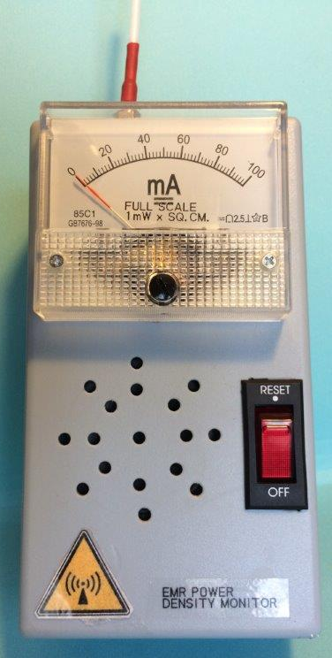
TECH: XE1XA ON MONITORING THE E&M RADIATION WITH A DENSITY POWER METER: Scientific evidence suggests that exposure to E&M radiation (EMR) in the range of 300 to 3000 MHz can be harmful for human health. High exposures can heat human tissues in a similar way to how microwaves cook our food, and the thermal effect can permanently damage tissues, especially the eyes, resulting in cataracts and other health disease. E&M field strength is measured in Volts per meter and Amps per meter, or in power density and expressed in Watts per square meter (W/sq.m.). To analyze how much EMR is absorbed by a body, the quantity used is expressed in Watts per kilogram (W/Kg.). For the personnel occupationally exposed to EMR, or those involved in experimental activities with high level of EMR, as on EME in amateur radio, the exposure level should be of concern. There is not yet a worldwide specific standard to set an exposure limit in power density, since it is ranging from 10 W/sq. meter (1mW/sq. cm.) to 1 W/sq. meter (0.1 mW/sq. cm.), or even less. This project it has been to design and test a Density Power Meter (DPM) that could be calibrated in mW/sq. cm. with the equipment usually available for experimental activities in the VHF/UHF Amateur Radio. A UHF diode senses the RF energy level captured by a probe. The rectified d.c. current drives an opto-coupler that controls an NE555 square wave audio oscillator, whose frequency can be varied from a few Hz to several KHz, depending on the intensity of the EMR field strength. At the output of the NE555 is a small speaker that monitors the audio freq, and a calibrated meter that shows the power density. For testing DPM, you just adjust R1 to read a D1 cathode voltage of 1.0 V, so that it will be starting to conduct d.c. current to a level of less than 1.0 mA. At this point the NE555 will start to oscillate by providing an audible “tac..tac” through the speaker. Adjust R1 to get an audio output of a few pulses per second. Make the length of the probe a quarter of a wavelength at the EMR freq under test. You can check the response to EMR by putting the DPM probe near the door of a microwave oven. The U.S. FDA standards has a legal limit of 5 mW/sq cm at 2 inches from the oven. To calibrate the Density Power Meter: the electric field strength is given by the formula: S = $WG/4πR^{2}$ W/m², where: S = Electric field strength in W/sq m and W = Power in Watts. G = Antenna Gain (numeric). R = Radius from source of the field to the DPM probe in meters. The Antenna could be a simple dipole with a gain of 2.2 dBi (1.659 numeric) or a horn feed with a known aperture area. I have been using a circular horn feed with an aperture diameter of 6” (0.152 m), and an estimated gain of η (πD/λ)². For η = 0.5, the horn feed gain is 2.13 (3.28 dBi). To get a reference power density level S of 10W/sq m (1mW/sq cm) at a distance R from the horn feed aperture, with 5 Watts of TX output power: R = SQRT(WG/4πS) = 0.29 m. Adjust R2 to get a full scale reading of 1mW/sq cm at the meter. AVOID DIRECT EXPOSURE WHEN CALIBRATING THE METER. Since the meter’s reading is proportional to the square of the RF voltage at the cathode of D1, a power density of 0.5 mW/sq cm will give a reading of ~ 70% of full scale; so that you could easily read power density down to 10 μW/sq cm. If the antenna is linearly polarized, align it in the same plane of the DPM probe. If circularly polarized, the full scale reading will be 5 W/sq m (0.5 mW/sq cm).

RADIO-ASTRONOMY CORNER (led by OK1TEH)

We have stated in previous issues that, in addition to the high-frequency gravity wave detector LIGO and its European counterpart VIRGO and KAGRA, there has been an effort for several decades to directly capture gravitational waves at very low frequencies thank to observing of Pulsars (IPTA). Not surprisingly, low-frequency gravitational waves of galactic origin are extremely difficult to detect. Their wavelength is measured in light years as it can be seen at following picture.

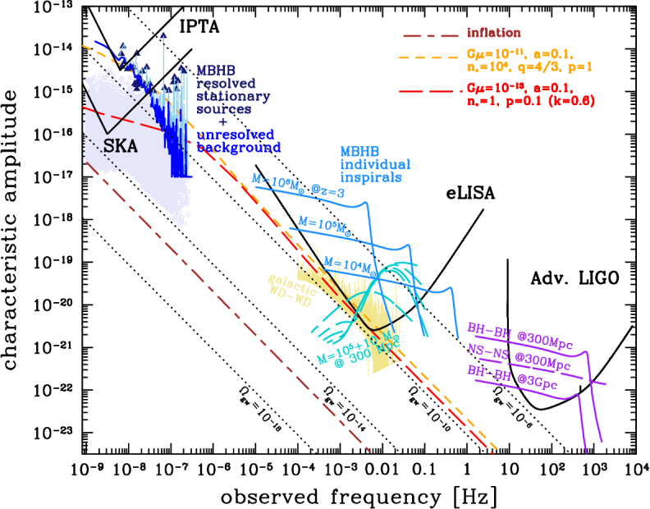

The NANOGrav project consists of terrestrial radio observatories that do not directly observe gravitational waves, but millisecond pulsars, ghostly beacons made of collapsed matter, flashing furiously in a very precise and at the same time stable rhythm. As gravitational waves pass through the radiation of these galactic sirens, they should slightly change its appearance. These are deviations in the order of nanoseconds and are being searched for by the NANOGrav project team.

The NANOGrav project currently monitors 54 pulsars. But he is not the only one. There are currently a total of three projects that collect data from the observation of a set of millisecond pulsars (pulsar timing array). In addition to the NANOGrav project, there is the Parkes Pulsar Timing Array project, which uses observations from the Australian Parkes radio telescope, and the European Pulsar Timing Array (EPTA) project, which in turn collects data from Europe's largest radio telescopes. In addition, all three projects are grouped into the International Pulsar Timing Array (IPTA) "project project".

After years of observation, the discovery of a statistically significant deviation at NANOGrav was reported on 21st January 2021, from which scientists appear to have indeed found something (!!). According to the head of research, astrophysicist Joseph Simon from the American University of Colorado Boulder, they have a strong signal in the data (by the way, also thanks to the analysis of the latest data obtained from the Arecibo radio telescope). For now, however, they cannot definitely confirm that this is indeed the gravitational background of the universe. But if they have succeeded or will succeed in the future, it will be a significant scientific achievement that will open up further opportunities for space exploration.

By the way, scientists dream of the "holy grail" of gravitational astronomy, that is, the capture of gravitational waves directly from the time of the Big Bang. Since the universe did not become transparent until some 400,000 years later, the CMB, or residual background radio radiation, dates back to this period. If gravitational waves from the time of the Universe could be detected, it could provide very valuable data, whether on new physics, primordial black holes, or the initial super-rapid Universe expansion at the beginning.

It seems that the year 2021 can bring a discovery as significant as the first direct photograph of the Supermassive Black Hole in Galaxy M87. Or at last it could be great push to get money to lunch of LISA satellites. We cross fingers!

For more see: http://nanograv.org/assets/files/slides/AAS_PressBriefing_Jan%2721.pdf

https://en.wikipedia.org/wiki/Laser_Interferometer_Space_Antenna

Jan, PA0SSB 1941-2021

Comment OK1TEH: I was asked by friends to write the life story of PA0SSB for the EME Newsletter of K2UYH, as I have been interested in EME history for a long time. I was lucky to meet Jan personally during the EME Conference 2018 in the Netherlands, where we talked for a long time not only about its EME beginnings, history, technology, but also about other things, and we exchanged a lot of interesting photos and information. Jan was not only a good friend, a joker, a great designer and collector of historical technology, but also an excellent musician and his playing the guitar in tandem with Dirk ON5GS was the culmination of a very successful meeting.

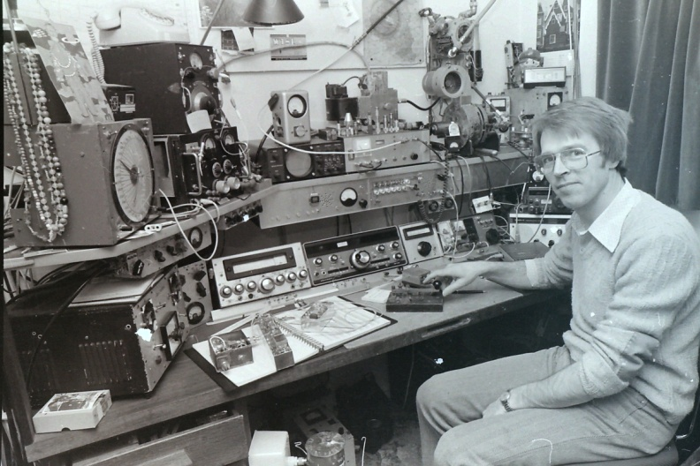

Jan Ottens was born on May 12, 1941 in the Dutch city of Pijnacker. The invasion of the Dutch by Nazi troops severely affected his family and friends. Although the war ended when Jan was only 4 years old, he remembered how long after the war he had experienced the reconstruction of the nearby Nazi-burned city of Rotterdam, when he discovered an air-raid shelter among the remains of buildings while playing in the ruins. When he opened the cover door, three human skeletons fell on him. Jan also remembered that he was strongly influenced by the story of a 16-year-old boy from his village who was delivering a resistance newspaper and who was shot in the square as a warning. When World War II ended, the decisive moment of his life came. Father Karl Ottens took his son by the house and said, "Son, now you will experience something." They began digging together and dug a "corpse" out of the ground, a radio hidden under the rocks for three years (if Nazi would found it he could had been shot). Jan recalled that the radio was in poor condition after 3 years in the soil and when they turned it on, he saw only light from valves, but after the repair it suddenly came out of voice and music, and since then Jan has become an enthusiast of electronics and technology. As John himself said, "Without technology, this terrible war would never have ended." In later years, he not only became a great collector of historical radio equipment, but even created a perfect replica of the German encryption machine Enigma.

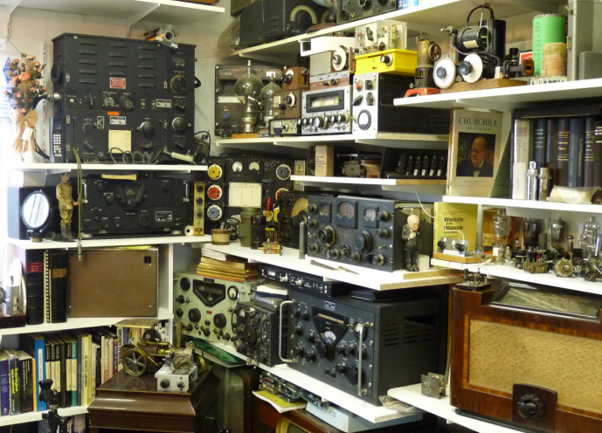
By the way, in addition to radio, Jan also remembered how his father had taken him as a little boy to watch post-war attempts to launch a V2 rocket from The Hague in the Netherlands, which gave rise to his great love for everything connected with space flights.

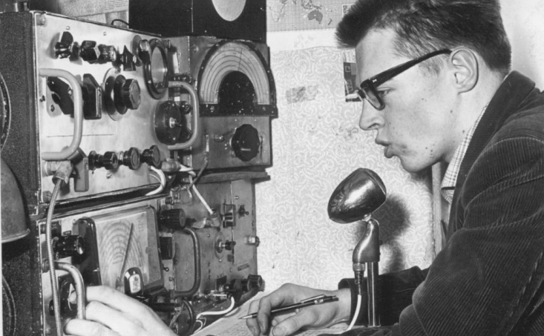
12 year old Jan in February 1953

In February 1953, Jan already had his own hamradio license and an article about him was published in the Dutch magazine Verona as a promising radio conctructer. In October 1957, Sputnik 1 was launched and Jan, of course, had to be there, at least on the radio, listening to his signals on his home-made receiver. In 1964, Jan got married, moved to town of Terhole and began building a larger antenna system for the VHF bands.

Apollo 11 landed on the Moon in 1969, and John's main target became the Moon. In addition to EME, he was also very interested in listening the astronauts, especially when he read an article in the QST magazine, where there was a report on the reception of Apollo 15 by K4AFC in the 13 cm band. Jan started looking for information and was very inspired by the 6m G3LTF dish with wooden ribs, which Peter successfully operated since 1967. Literally a treasure was the American technical collection, in which Dick W2IMU (who by the way worked in Bell Laboratories) published a detailed drawing of his EME dish. Shortly afterwards, Jan began to build 3.1 m long ribs for his own 6m dish. Each rib was made by cutting a 2.5 cm wide strip of 1.5 x 3.00 and 3 mm thick aluminum sheet into the desired parabolic shape. An aluminum tube with a diameter of 10 "was used in the middle, which served as the hub of the dish.

The dish had an AZ / EL assembly, the "heavy duty" azimuthal engine Jan obtained at a landfill in Belgium and originally came from a German war radar. The mesh came from a chicken farm. For transmission and also for his first EME connection he used a PA with 2x2C39, which gave around 70-80W out.

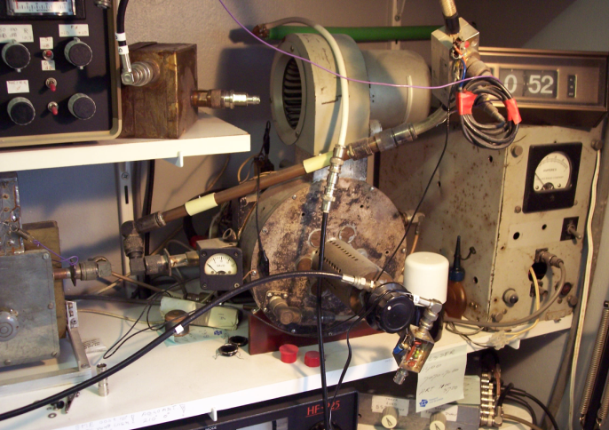

For reception at 23cm, Jan first built a functional copy of the parametric receiver K6UQH according to an article in QST, but soon upgraded to a solid state LNA with 2xBFR90 from Philips, which had a noise figure around 3dB.

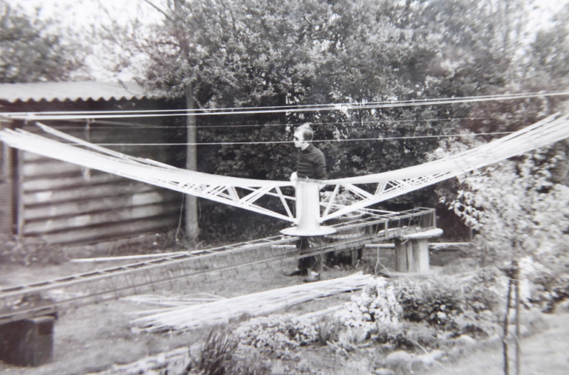

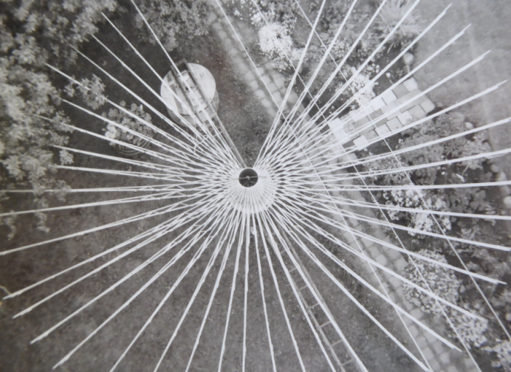

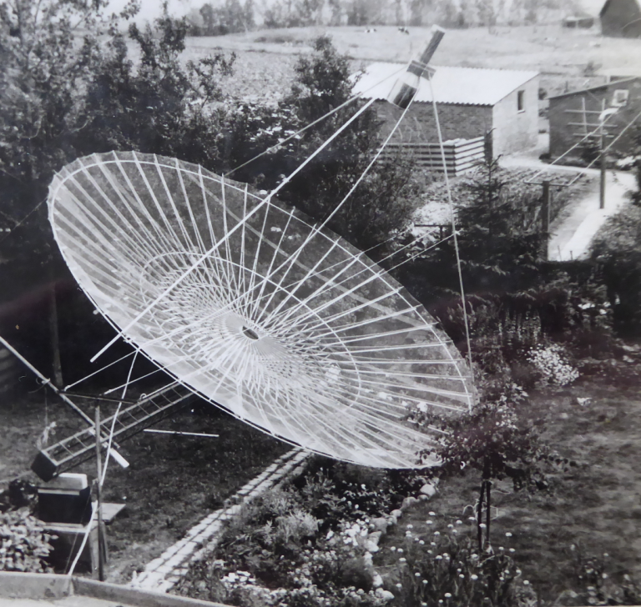

As it was announced after the Apollo 13 crash that the Apollo 18, 19 and 20 lunar expeditions were canceled, Jan tried to have a dish completed by the start of the last Apollo 17 lunar mission scheduled for December 1972. This meant, among other things, digging and concreting 2m deep hole for the base. Jan completed the dish in mid-June 1972 and made his first solar noise measurements on June 25, 1972, when he measured 10dB of Sun. But it soon became clear that a 6m dish would be blocked by a nearby house at Moonrise. So Jan decided to move the already finished dish to the opposite end of the garden. 6 friends helped him with the manual transfer of the heavy dish. When they were carrying the dish, a car was passing by and the driver, when he saw the "circus", was said to be quite exposed, he probably thought that the Martians had just arrived.

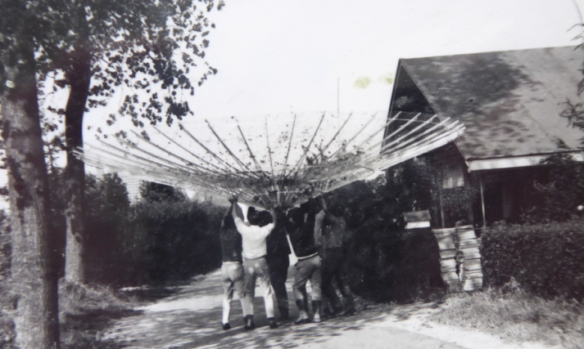

Two days after transferring and installing the dish to the new location, a strong storm came, and in the absence of a counterweight, there was not much left to destroy the dish. Afterwards, Jan placed a 300 kg counterweight and a wind safety device over the auxiliary pulley. After this upgrade, the dish has survived on the mast to this day.

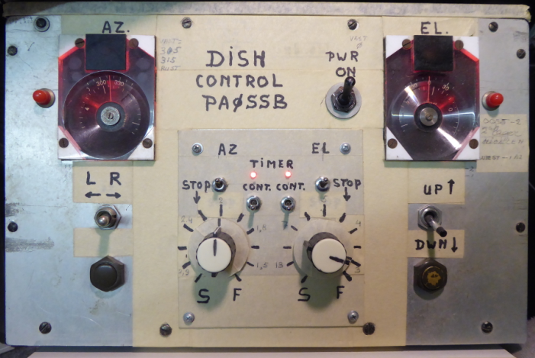
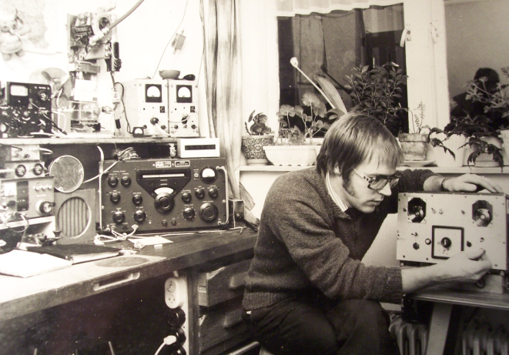

By the way, you would probably be interested to know how Jan solved the control of the parabola in AZ and EL. At the turn of the 60's and 70's, most stations used parallactic mounting, because this solution was more advantageous due to the use of only one transmission. Jan was one of the first stations in Europe to use AZ / EL montage. For the indication, he used a surplus device from a German WW2 radar with an accuracy of 0.1 degree, when in the 13 cm band he had to adjust manually the setting in AZ every 2 to 3 minutes (elevation was not so critical because it was slower). Because the use of computers was very rare at that time, most stations used Almanac naval tables. However, Jan was lucky to come met W1HBA during the regular chat at the VHF-net on 14,345 MHz, who at that time had access to a large computer center and, as an enthusiastic programmer for Jan's QTH, calculated the position of the Moon with a 0.5deg step to several months in advance.

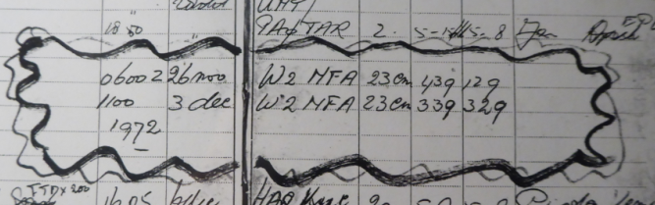

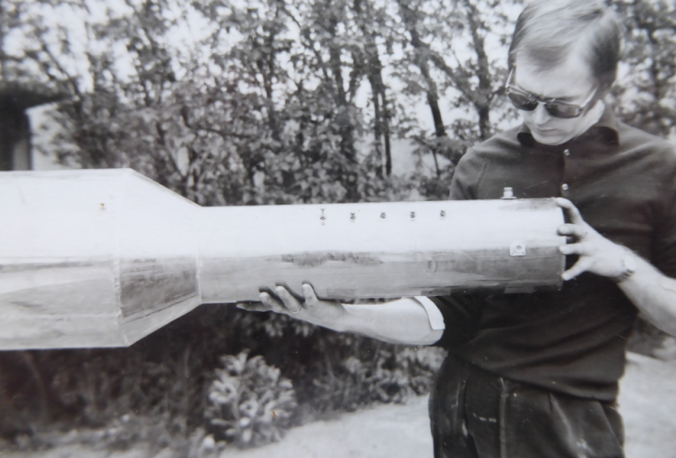

Jan established his first EME QSO on November 26, 1972 at 06:00h UTC, when he established a contact with the W2HRA and then repeated this QSO on December 3. It was interesting for the QSO that the sked was successfuly finished only shortly before the sked made at VHF-net on 14,345 MHz. W2HRA in New Jersy used an 18m Keneddy dish, a noise figure of 3dB and 400W of power input from a PA UPX-4. The exchanged reports were in the strength of 439 and according to Jan they were in the peaks up to 18dB above the noise and the average strength was around 6 to 10dB above noise. At that time, this was the first contact from the Netherlands via EME with completly homa-made equipment. The description of Jan's equipment and antennas was soon published in the popular American anthology Eimec, and Jan's design became the benchmark for other EME stations.
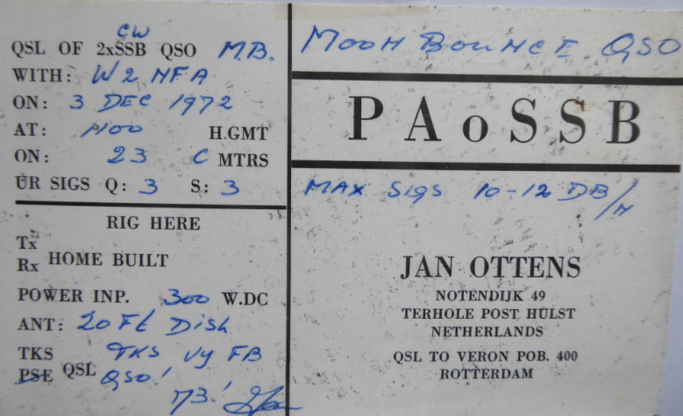
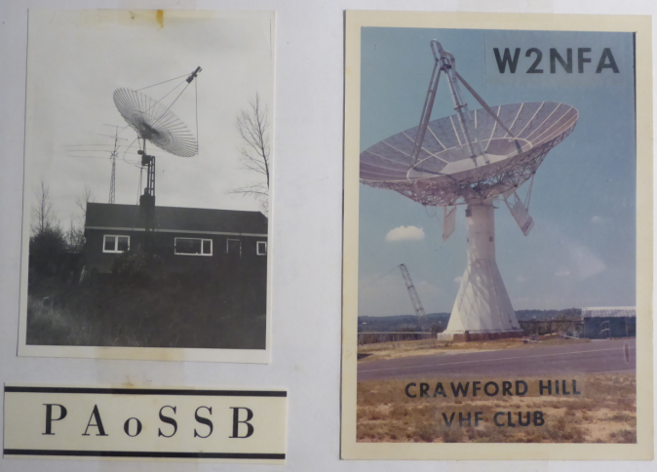

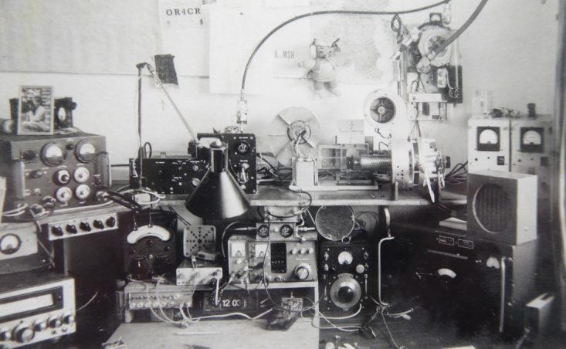

Shortly after the first successful QSO on December 7, Apollo 17 mission took off from Earth and Jan was ready. Long before the Apollo 17 flight, he wrote a letter to NASA asking for accurate data on the frequencies used, and received a very comprehensive response to his letter, sending him a number of documents and spreadsheets from NASA. By the way, he used a dual mode horn feed according to W2IMU for RX, which he created by connecting 3 oil cans, to which a diode mixer was directly connected. On December 11, at 6:30 p.m., Jan clearly heard a signal from the command module (CSM) orbiting the Moon at a strength of 10dB above the noise. After 10 minutes, the signal went gone due to shadowing on the Moon's surface, after which the signal returned after an appropriate time. After the astronauts landed on the surface of the Moon, they placed a beacon operating in the 13 cm band on its surface. Jan then used this beacon for a long time for accurate alignment of the dish aim. John was the only European amateur radio station to listen to Apollo signals from Europe, including (recorded) astronauts' conversations with the control center.

The following year, Jan established a number of QSOs via EME, for example with G3LTF and OZ9CR. In February 1975, he received an honorary diploma from Verona for the first contact between the Netherlands and Australia. In the same year, the American expedition W6LET also started 432 MHz EME experiments from the 45 m SRI radio telescope in Stenford. Although the W6LET signal was received by a number of European stations, the only connection from Europe was done only by PA0SSB. At the same time Jan listened to the Sun's noise 9dB above the noise and used 1kW PA with a 2.0dB NF LNA. Shortly afterwards, a number of other stations established a connection with W6LET in 1976, including OK1KIR.

In the fall of 1976, the first EME expedition to South America HK1TL took place, operating in the 432 MHz band. Thanks to the connection with this expedition, Al K2UYH reached the last continent and received the first ever 432 MHz WAC doploma in the world. Half a year later, on May 20, 1977, Jan PA0SSB received a 70cm WAC diploma too and became one of the first European stations to receive this diploma (others in the same year were: G3LTF, K3PGP, I5MSH, VE7BBG and W1SL).

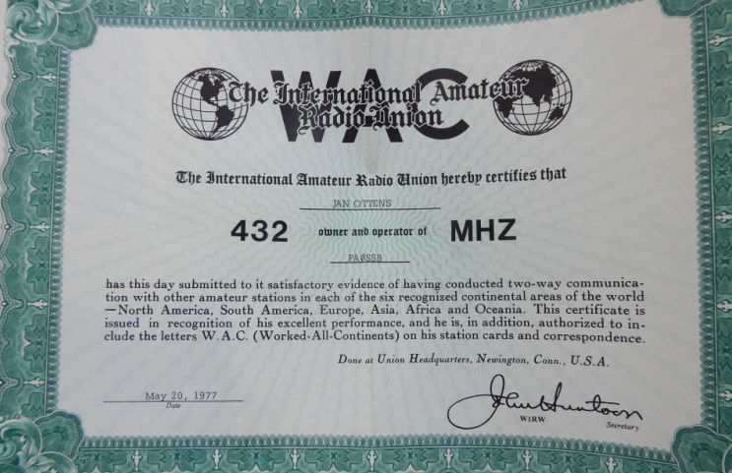

In the following years, Jan continued his activity at EME, in 1983 he set a new world record at 23 cm by working a QSO with ZL3AAD at over 18,500 km. Peter G3LTF remembers that Jan had an amazing SSB signal and together with Cor VE7BBG (SK) they had 20-30 minutes long regular SSB EME talks/skeds.

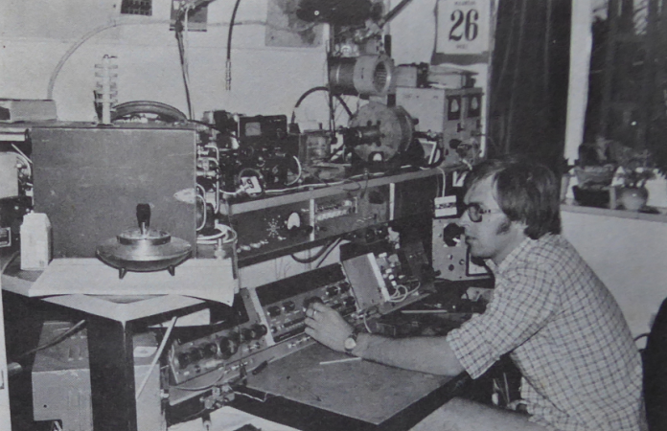

But everything is not just EME. Jan had an amazing historical collection of several unique radios, instruments, and as Dirk ON5GS mentioned, in addition to a faithful copy of Enigma, Jan also created an incredibly modified electric guitar with a home synthesizer, in which he used only sprung pieces of copper PCB to play chords without strings. The synthesizer was built using a 10MHz oscillator.

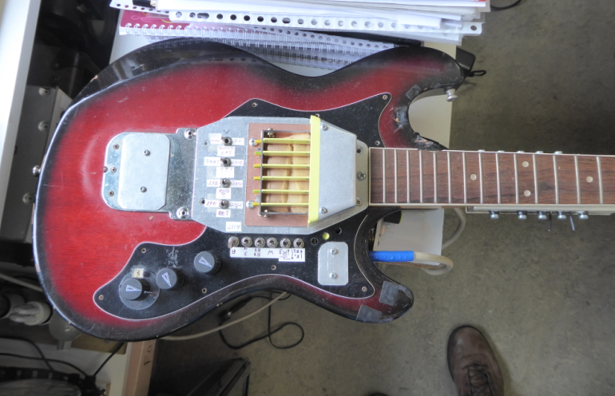

Jan continued his construction and operation via the QO-100 satellite, almost until January 4, 2021, when he died suddenly after short ilness.

Jan was an amazing person who inspired a large number of EMEers and hams. RIP dear Jan, you'll be not forgotten!

FINAL: This month we have F1EHN’s Moon Tables at the end of this NL. Thank you JJ.

► The results of the 2020 Dubus/REF CW/SSB EME Contest are now on the website http://www.marsport.org.uk/dubus/eme.htm. Top multiband is OH2DG, 432 UA3PTW, 1296 OK1CA and OK2DL - tied, 2320 OK1KIR, 3400 SA6BUN, 5760 SA6BUN, 10368 OK1LPR, and 24000 OK1KIR. [TNX DL8HCZ/CT1HZE for this effort compiling the results]! To support this contest, consider to subscribing if you do not already to the DUBUS Magazine. It`s easy! Just send 30 Euro with PAYPAL to DUBUS@t-online.de.

► 10 and 24 GHz Beacon (DL0SHF) Status: Charlie (G3WDG) reports that Per (DK7LJ) unfortunately had to go back into hospital for some further surgery on his back. [He may be home by now]. There were some small repairs that needed to be done before the beacon could be made operational again. It was not possible to complete these before he went into hospital. Per estimated that the beacon would not be QRV again for about a month. We are all wishing him a successful operation and a speedy recovery!

► K1DS thanks everyone for all the logs. Rick says this should be a good year for submissions.

► PA0PLY’s excellent and very helpful EME Directory/database has been added to the header of the NL. This should have happened years ago. We are sorry for the omission. Jan is adding directories for
listings for 47 GHz and 76 GHz stations. He asks that stations active on these bands to please send him their information.

► Take a look at OK1KIR’s report for an interesting and helpful observation for eliminating WIFI interference.

► See I0NAA’s report for info on is new version of Murmur.

► I am afraid we are running behind schedule again. We had hoped to send out this NL at least 2 weeks ago to better promote the Dubus 13 cm Contest and the SSB Funtests. (We are holding the results of the Funtests for the next NL). We have titled this one the Jan/Feb issue because of the delay. Thanks for all the excellent activity reports and tech material. Although we have not included most of the THANK YOUs for QSOs and great signals in the reports, they are tremendously appreciated by those who take the time to send in their reports. Coming up in Feb is the Dubus 432 CW weekend. Let’s all try and make this one. Even if you don’t normally operate CW, give it a try. The 20/21 Feb weekend will attract plenty of activity no matter what mode you operate. 73 and stay well, Al – K2UYH and Matej – OK1TEH.

